O & M MANUAL

Stills Pharmacy – New Chemist Development

Ref - GES157

GES ELECTRICAL LTD
Unit 1 Empress Court
St Andrew Street
Greenock
PA15 4RW
Tel/Fax 01475 713462

I N D E X

D E S C R I P T I O N S E C T I O N No.

Introduction 1

Warning Notes 2

Operating Instruction 3

Servicing 4

Light Fittings/Spares and Parts List 5

Distribution Panel/Parts List 6

Cable/Miscellaneous List 7

Inspection & Test Certificates 8

Contract Drawings 9

S E C T I O N O N E.

Introduction.

GES ELECTRICAL LTD carried out the electrical installation at Stills Pharmacy.

This operation manual provides detailed information for maintenance engineers in the future for guidelines of replacement part and guidelines to maintenance.

No arbitrarily ruling can be given regarding the length of time to lapse between periodic inspection as obviously this depends on the client and the infrastructure of maintenance, security, site environmental and climate conditions. We as a company would recommend that the client implements a maintenance schedule to be carried out on a regular basis, experienced personnel in the electrical field should implement this and a form of record left in this file.

It should be noted that before carrying out any maintenance checks or adjustments of any electrical components, the equipment should be isolated and locked off from the source of electrical power supply.

For and on behalf of

GES ELECTRICAL LTD

S E C T I O N T W O.

WARNING NOTES.

- Do not fit fuses and MCB of larger capacity than supplied within the electrical distribution panel or any fusible item.

- Make sure a full compliment of spare parts e.g. lamps for light fittings are always available, particularly parts most often replaced, and a record left.

- Maintenance should be carried out by experienced, qualified electrical personnel only and safe isolation procedures implemented at all times when works are being carried out.

- The cause of any circuit breaker to trip must be investigated and eliminated at all times

before the power be reapplied to any circuit.

S E C T I O N T H R E E.

Operating Instructions.

Electrical Distribution

- The main electrical distribution is situated in the basement level of the building. Scottish power cable head is situated to the left hand side of the main electrical panel’ with there 3-phase 4.5v main switch situated on the wall next to the mains panel, this switch if switched to the “OFF” position would isolate the main incoming power supply to the electrical installation within the building.

- Localised isolation of circuits can be done from the main electrical panel. All circuit breakers have a legend explaining a brief detail of its operation located to the centre of the panel. Each circuit breaker clearly states whether it is in the “ON” position or the “OFF” position for maintenance purposes circuit breakers should be locked off and labelled clearly that personnel are working on circuit, we recommend that a clear procedure be put in place by client to ensure that this is adhered to at all times and by Experienced electrical personnel only.

Lighting

- All light fittings are operated via localised switches in each room of building.

Emergency Lighting

- Next to each light switch an emergency light test switch is located this is for maintenance purposes only – please refer to emergency lighting section for a more detailed account of operation.

Power Socket Outlets

- All socket outlets are 240v 13amp 3-pin outlets, please note that all appliances should have correct fuse value installed and be certified portable appliance tested. All socket outlets have RCD protection.

Fire Alarm

- Fire Alarm System is a fully automated system, consisting of fire alarm panel situated at front entrance, combined sounder and smoke detection situated at the roof level and emergency break glasses situated at each exit/entrance to building.

Outside Lighting

1. Outside lighting can be operated via switch in the main reception area located on side wall of I.T. cupboard.

S E C T I O N F O U R.

Servicing.

SERVICING OF THE CONTROL GEAR, SWITCH GEAR, LIGHTING, FIRE ALARM SYSTEM – Should be carried out by Experience Personnel only.

- Inspect for loose connections, and tighten nuts, bolts, electrical connections, care should be taken when removing any covers, always make sure all exposed electrical connections have been isolated before carrying out any servicing.

- Examine all switches, control gear, distribution, and lighting socket outlets for signs of overheating or wear and tear, replace if necessary.

- Check all fuses have the correct rating and are in healthy condition.

- Log and report all servicing and list all new parts within this folder.

S E C T I O N F I V E.

Light Fittings/Lamps

JCC JC50325 SURF SUSP BLADE EXIT SIGN
JCC JC50310 LEGEND 2 X DOWN RUNNING MAN
JCC JC50506 LED DOWNLIGHT RECSD 3W WHITE
AC8208 CAT 5E UTP 24 PORT RJ45 PANEL
LGA SE-BHLD-9 3HRM LED BULKHEAD 3W
600X600 LED PANELS
LUNAR 18W LED DECORATIVE BULKHEAD WHI/OP 1400LM, IP54, IK08 & 4000K
LED BULKHEAD EMERGENCY/MICROWAVE SENSOR 2D FITTING 16W FITTING IP54 WHITE BASE
SAXBY 73535 REEVE 2 LED DISPLAY 45W X 18
LGASE-BHLD-9 3HRM LED BULKHEAD 3W
LED EMERGENCY BULKHEAD 1.5HR LED EMERGENCY DO
CUDIS MH320C TP MCB 20A 10KA
LED BULKHEAD EMERGENCY/MICROWAVE SENSOR 2D FITTING 16W FITTING IP54 WHITE BASE

S E C T I O N S I X.

Distribution Panels/Parts List

S E C T I O N S E V E N.

Cable/Miscellaneous

ACEL AC77702 CHANNEL 41X21MMX3M SLOTTED
ACEL AC2403 AC2403 NUT & BOLT M6X25MM BZP
ACEL AC7777G PENNY WASHER M6
AC777635 M DUTY WRAPOVER COUPLERS PAIR
A2W 2MM WIRE (100M REEL)
KL/100 WIRE CLIPS
ACEL AC777632 CABLE TRAY MD 150MMX3M
CABLE 6243BH 1.5MMX100WHITE
CABLE 6243BH 2.5MMX100WHITE
ACEL AC76002 RND H/D CONDUIT 20MMX3M WHI
ACEL AC76036 STANDARD BEND 20MM WHI
ACEL AC76064 FEM THREAD ADAPTOR 20MM WHI
BG CMP9232 2G BOX PATRESS 32MM WHITE
BG CMP9132 1G BOX PATTRESS 32MM WHITE
ACEL AC1002 SOCKET 2G SWITCHED 13A WHI
ACEL AC11048 FRY LINING BOX 2G 35MM WHI
ACEL AC11047 DRY LINING BOX 1G 35MM WHI
ACEL AC2596 STRIP CONNECTOR 12 WAY 15A
ACEL AC2596 STRIP CONNECTOR BOX
ACEL AC2546 CABLE SLEEVING 4MM G/Y
ACEL AC76046 SPACER BAR SADDLE 20MM WHI
AC777403 CABLE TRUNKING 100X100MMX3M
ACEL AC777473 STOP END 100X100MM
ACEL AC7375 MALE BUSH LIGHTS 2IN BRASS
ACEL AC7364 LOCKRING 2UN SELF COLOUR
ACEL AC1012 CONNECTION UNIT SWD NEON 13A
ACEL AC1001 SOCKETS 1G SWITHCED 13A WHI
ACEL AC1023 PLATE SWITCH DP F/O NEON20AX
ACEL AC1013 PLATE SWITCH 1G 1 WAY WHI
ACEL AC1018 PLATE SWITCH1G TP WHI
ACEL AC1015 PLATE SWITCH 2G 2WAY WHI
ACEL AC11805 CONNECTION UNIT UNSWD 13A
ACEL AC3201 ROTART ISOLATOR ENC 4P 25A
COOPER CFEAPULL KIT DISABLED TOIL ALARM
ACEL AC76006 CIRC TERM BOX 1WAY 20MM WHI
SCEL AC76072 CIRCULAR LID 65MM WHI
AC1167 24HRMECHANICAL IMMERSION 16A
ACEL AC8215 1 GANG FACEPLATE 2 MOD
ACEL AC8206 25X50MM RJ45 CAT 5E MODUAL
CUDIS ROSB106C/030 1 MODULE RCBO 6A
CUDIS ROSB110C/030 1 MODULE RCBO 10ª
CUDIS ROSB116C/030 1 MODULE RCBO 16A
CTEC CFP702-2 FIRE PANEL 2 ZONE 2 WIRE
YSASA NP3.2-12 3.2AH 12V BATTERY
MCPIA MANUAL CALL POINT
PS200 MANUAL CALL POINT PLASTIC FLAP
55000-390APO OPTICAL SMOKE DETECTOR
45681-244APO ALARM SENSE BASE
55000-392APO OPTICAL SMOKE/SOUNDER BASE
55000-196APO HEAT DETECTOR/SOUNDER BASE
55000-835APO ALARM SENSE ALARM RELAY
CONTAC 3467MR CONN UNIT KEY SW NEON 13A
ACEL AC66100 100MM STANDARD FAN
ACEL AC66130 150MM STANDARD FAN
ACEL AC6179 DUCT 150MM X 6M
ACEL AC6178 DUCT 100MM X 15M
ACEL AC6177 DUCT 100MM X 6M
SNG PATRESS BOX
SNG FAST FIX BOX
CPN TYPE D 20A S/P MCB
GREENBROOK MECHANICAL TIMER 230V
CABLE 6944XLH 2.5MM 7/0.67 BLACK
ACEL AC2601 CBL/GLD 2 PK BW INDOORS 20MM
GREENBROOK T100 24 HOUR MECHANICAL TIMER
BG CMP9132 1G BOX PATTRESS 32MM WHITE
ACEL AC7376 MALE BUSH LONG 20MM BRASS
ACEL AC7356 LOCKRING 20MM SELF COLOURED
ACEL AC2540 CABLE SLEEVING 3MM G/Y
ACEL AC77776 PENNY WASHER M6
ACEL AC777473 STOP END 100X100MM
ACEL AC76006 CIRC TERM BOX 1WAY 20MM WHI
ACEL CIRCULAR LID 65MM WHI
ACEL AC76064 FEM THREAD ADAPTOR 20MM WHI
ACEL AC11048 DRY LINNING BOX 2G 35MM WHI
ACEL AC7920 U BOX 20MM GALVANISED
ACEL AC1012 CONNECTION UNIT SWD NEON 13A
ACEL AC1041 PATTRESS SURFACE 1G 25MM WHI
CUDIS ROSB120C/030 1 MODULE RCBO 20A
CONTAC 3467MR CONN UNIT KEY SW NEON 13A
CABLE 6242BH 2.5MMX100M WHITE
PRYS FP200G2C1.5 RED 100M

S E C T I O N E I G H T.

Inspection & Test Certificates

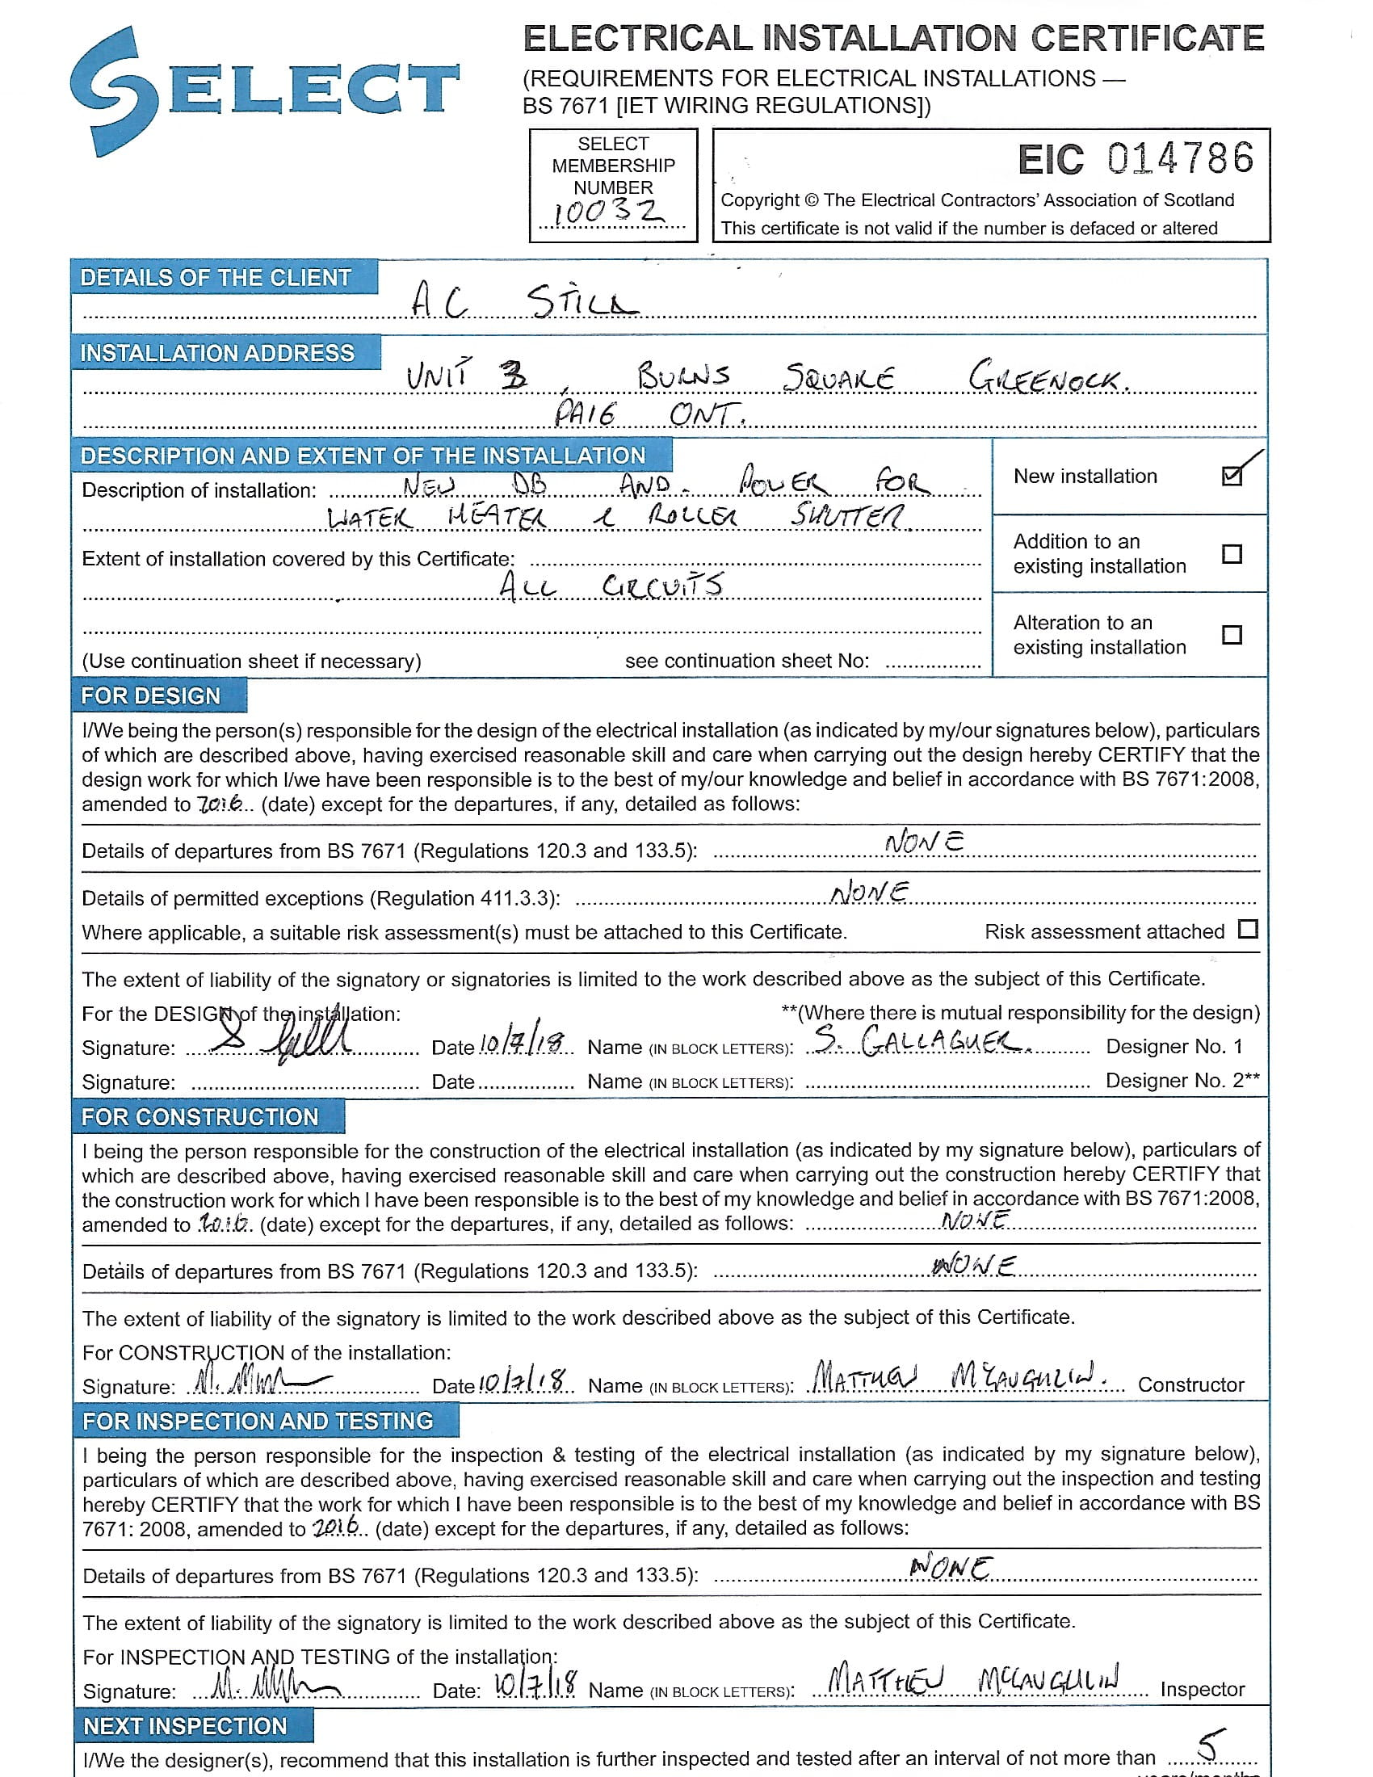

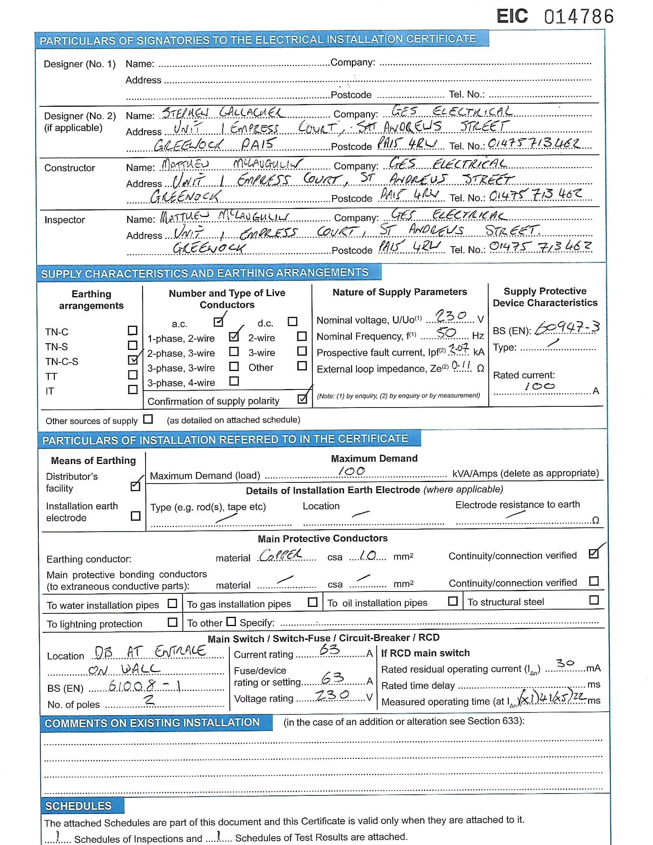
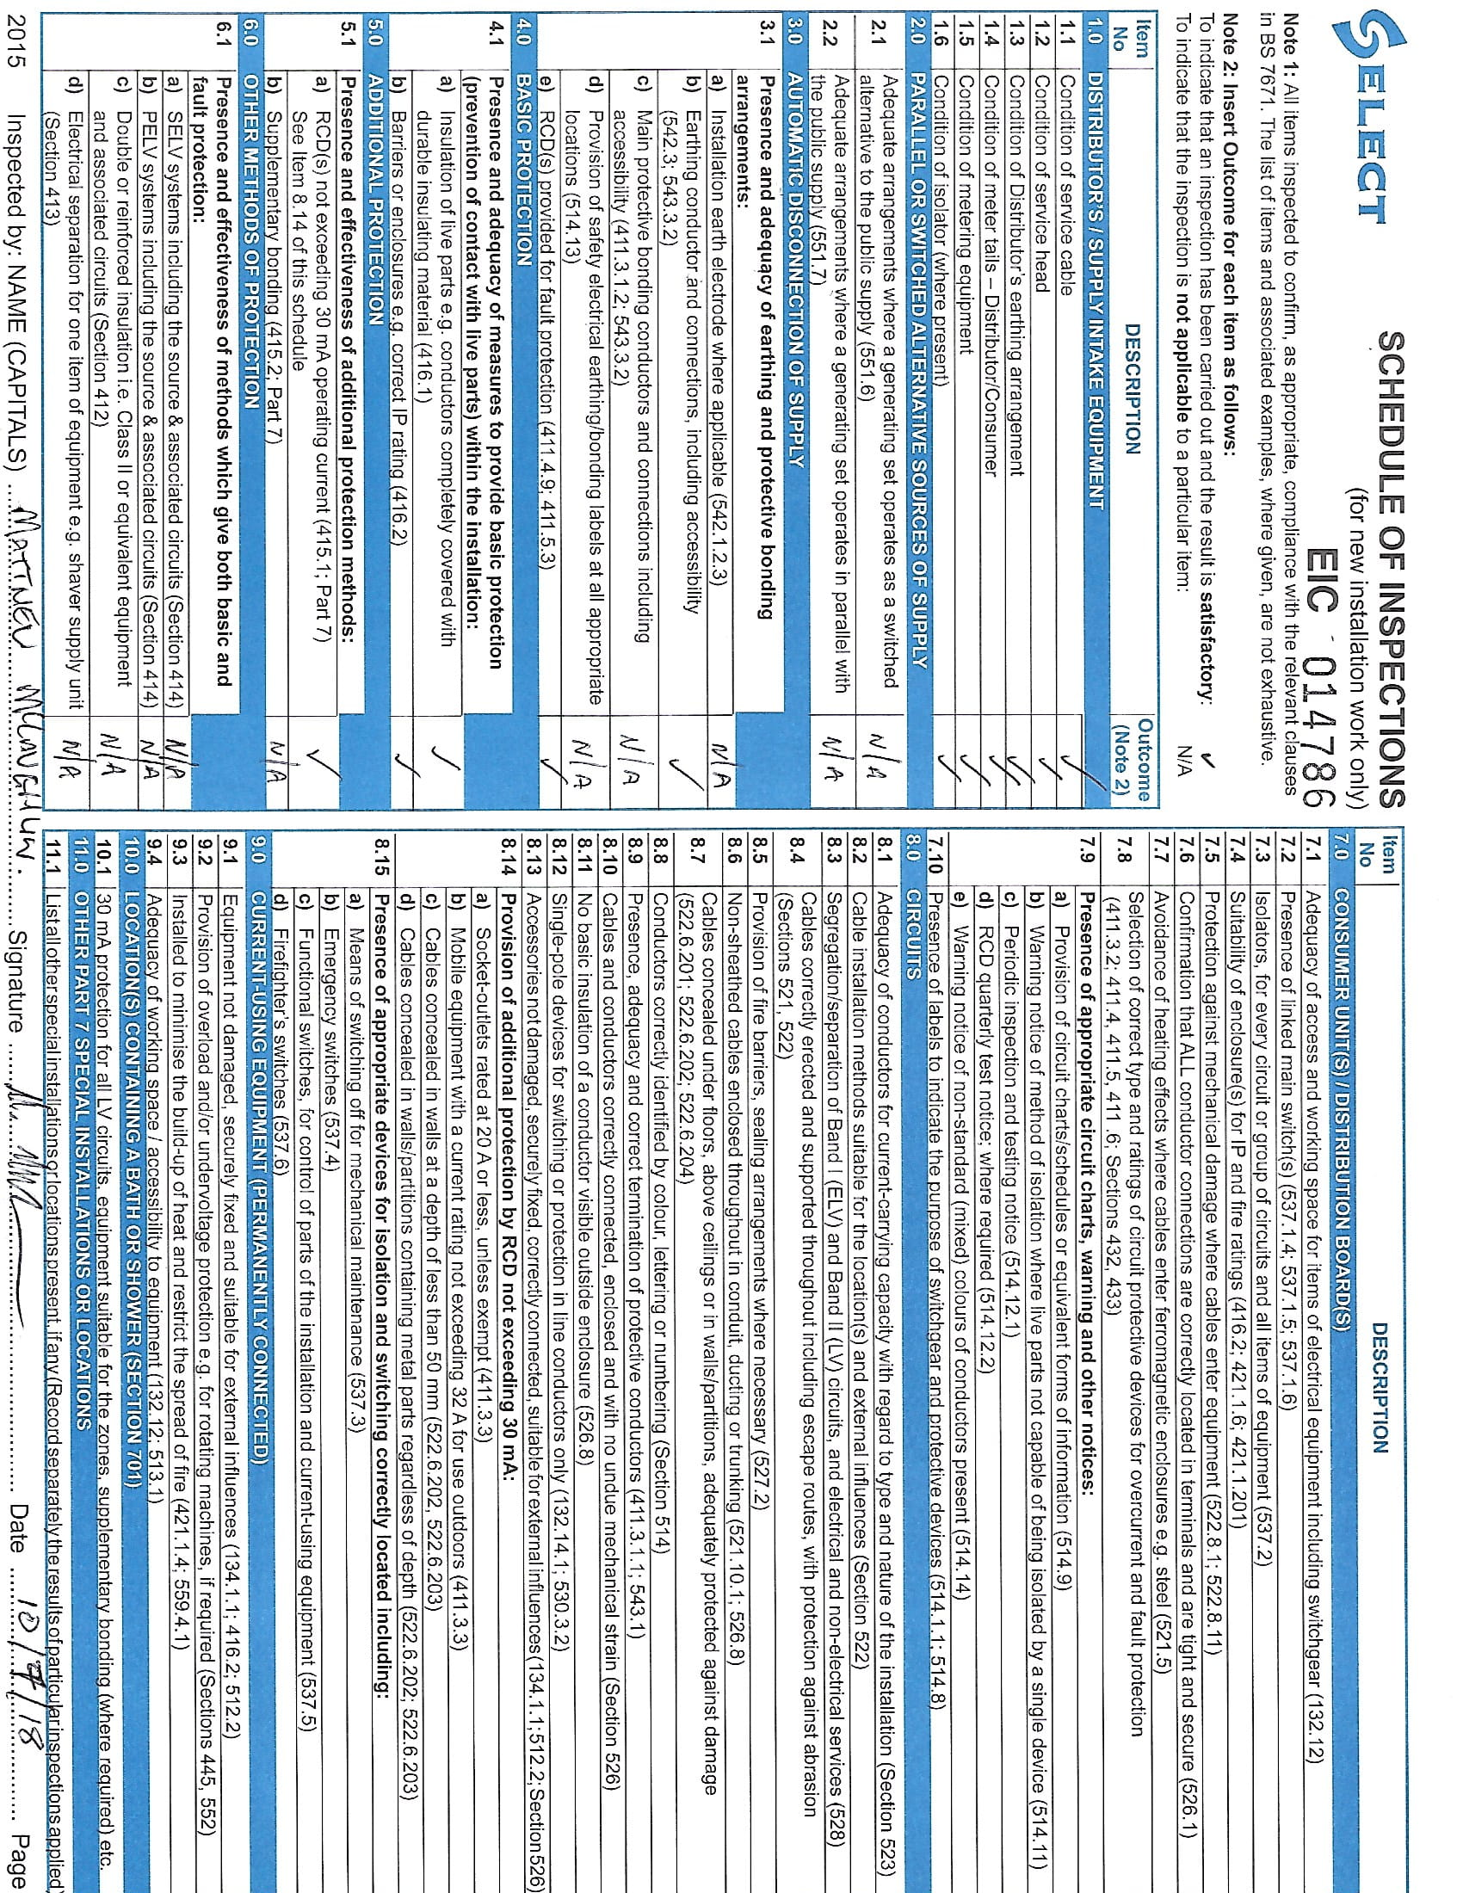

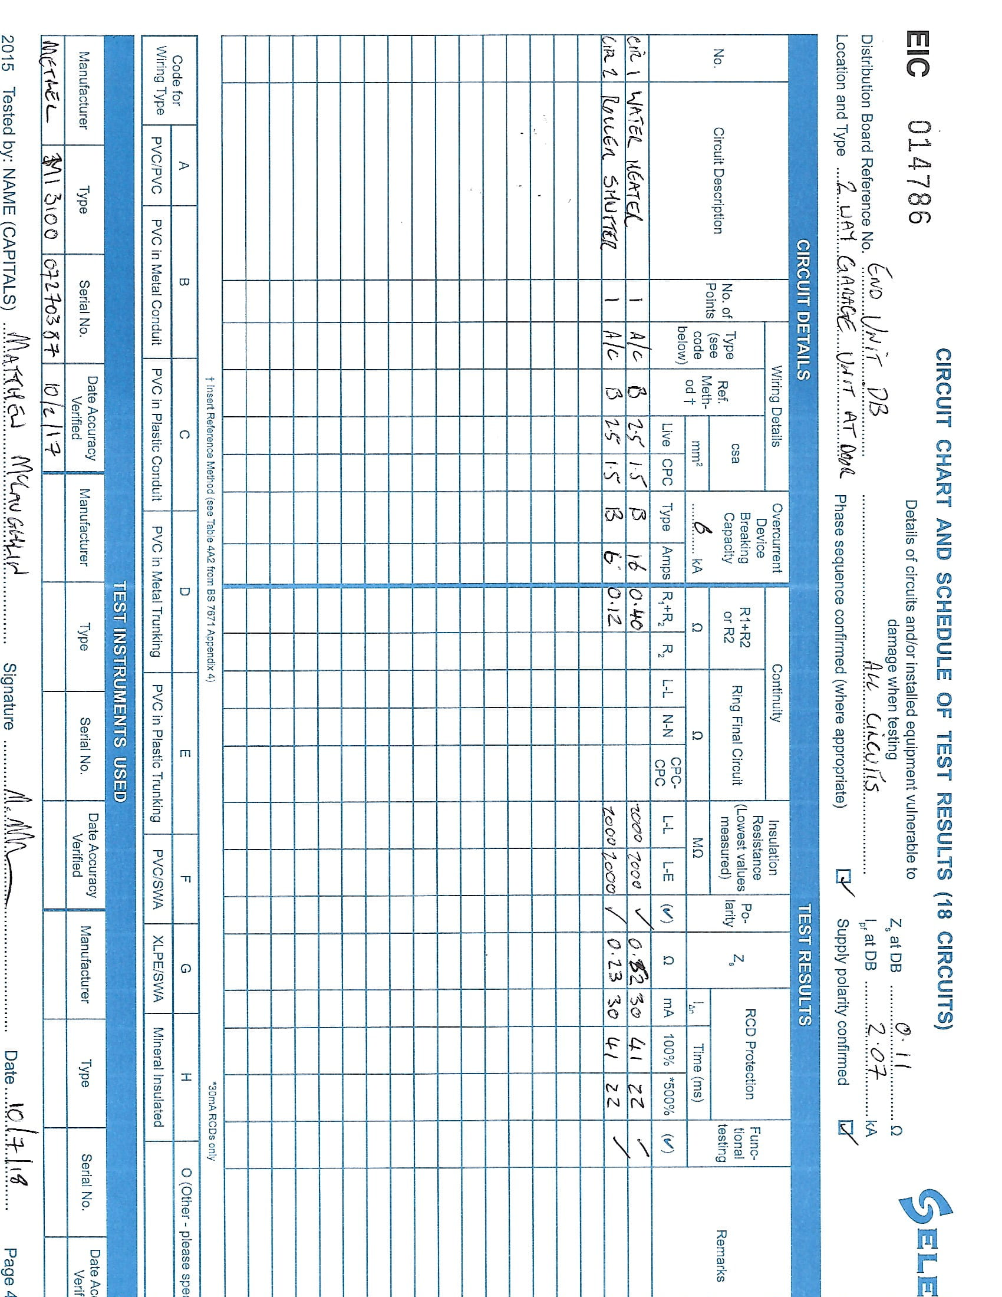
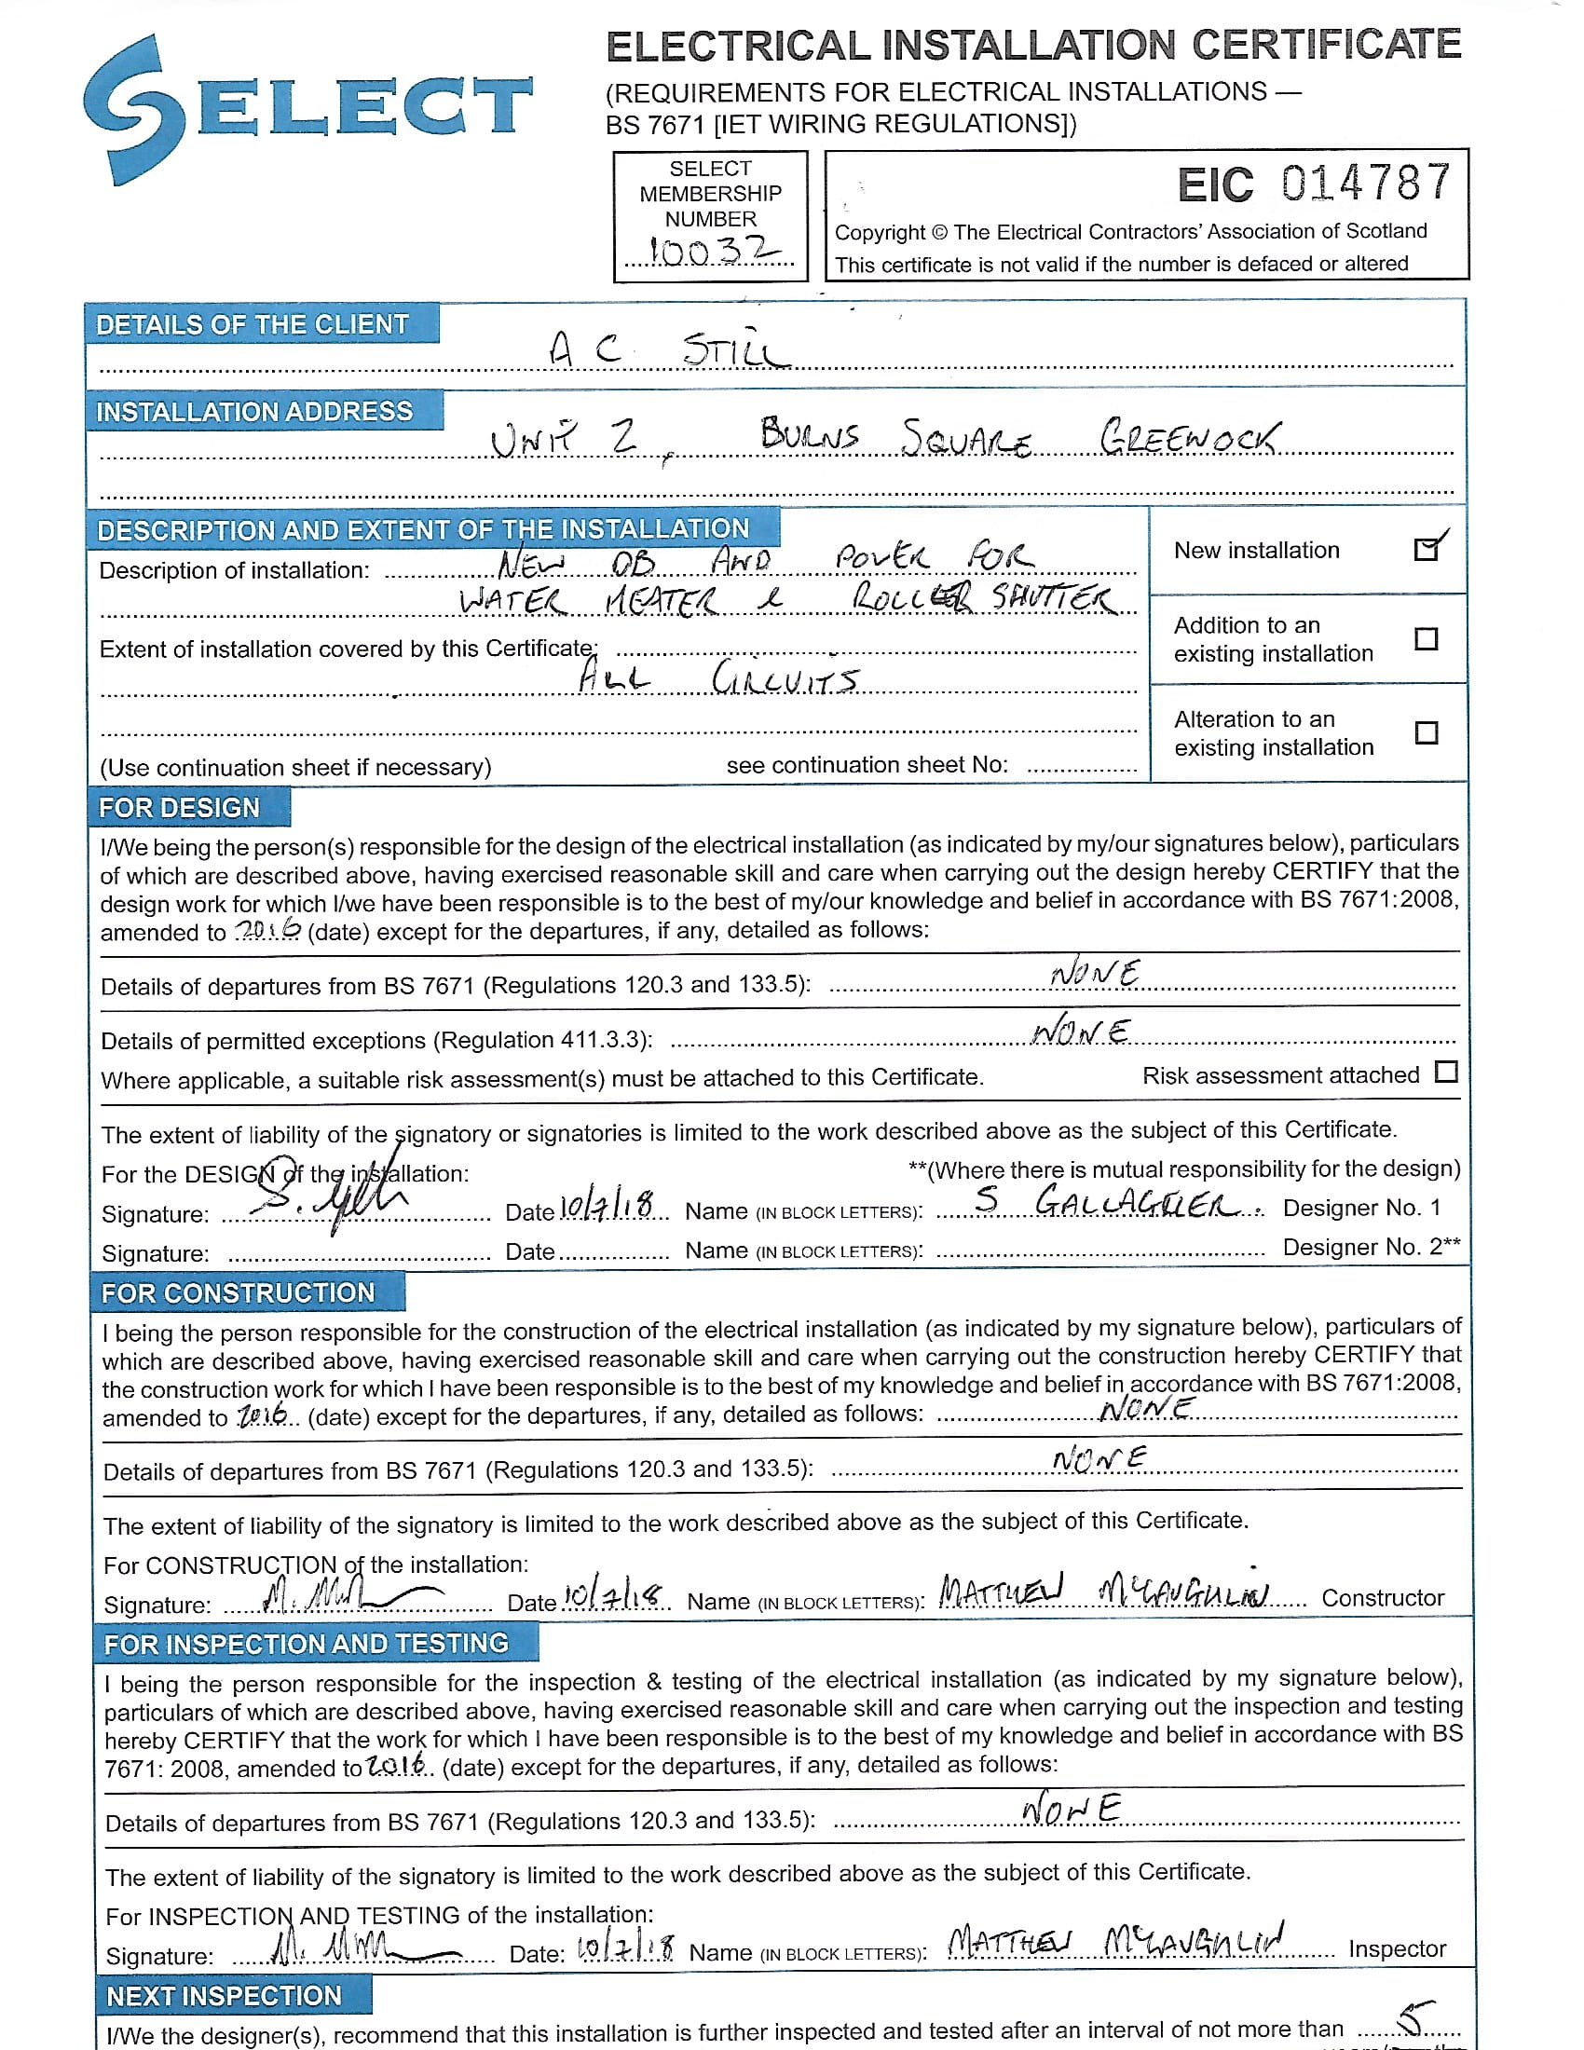
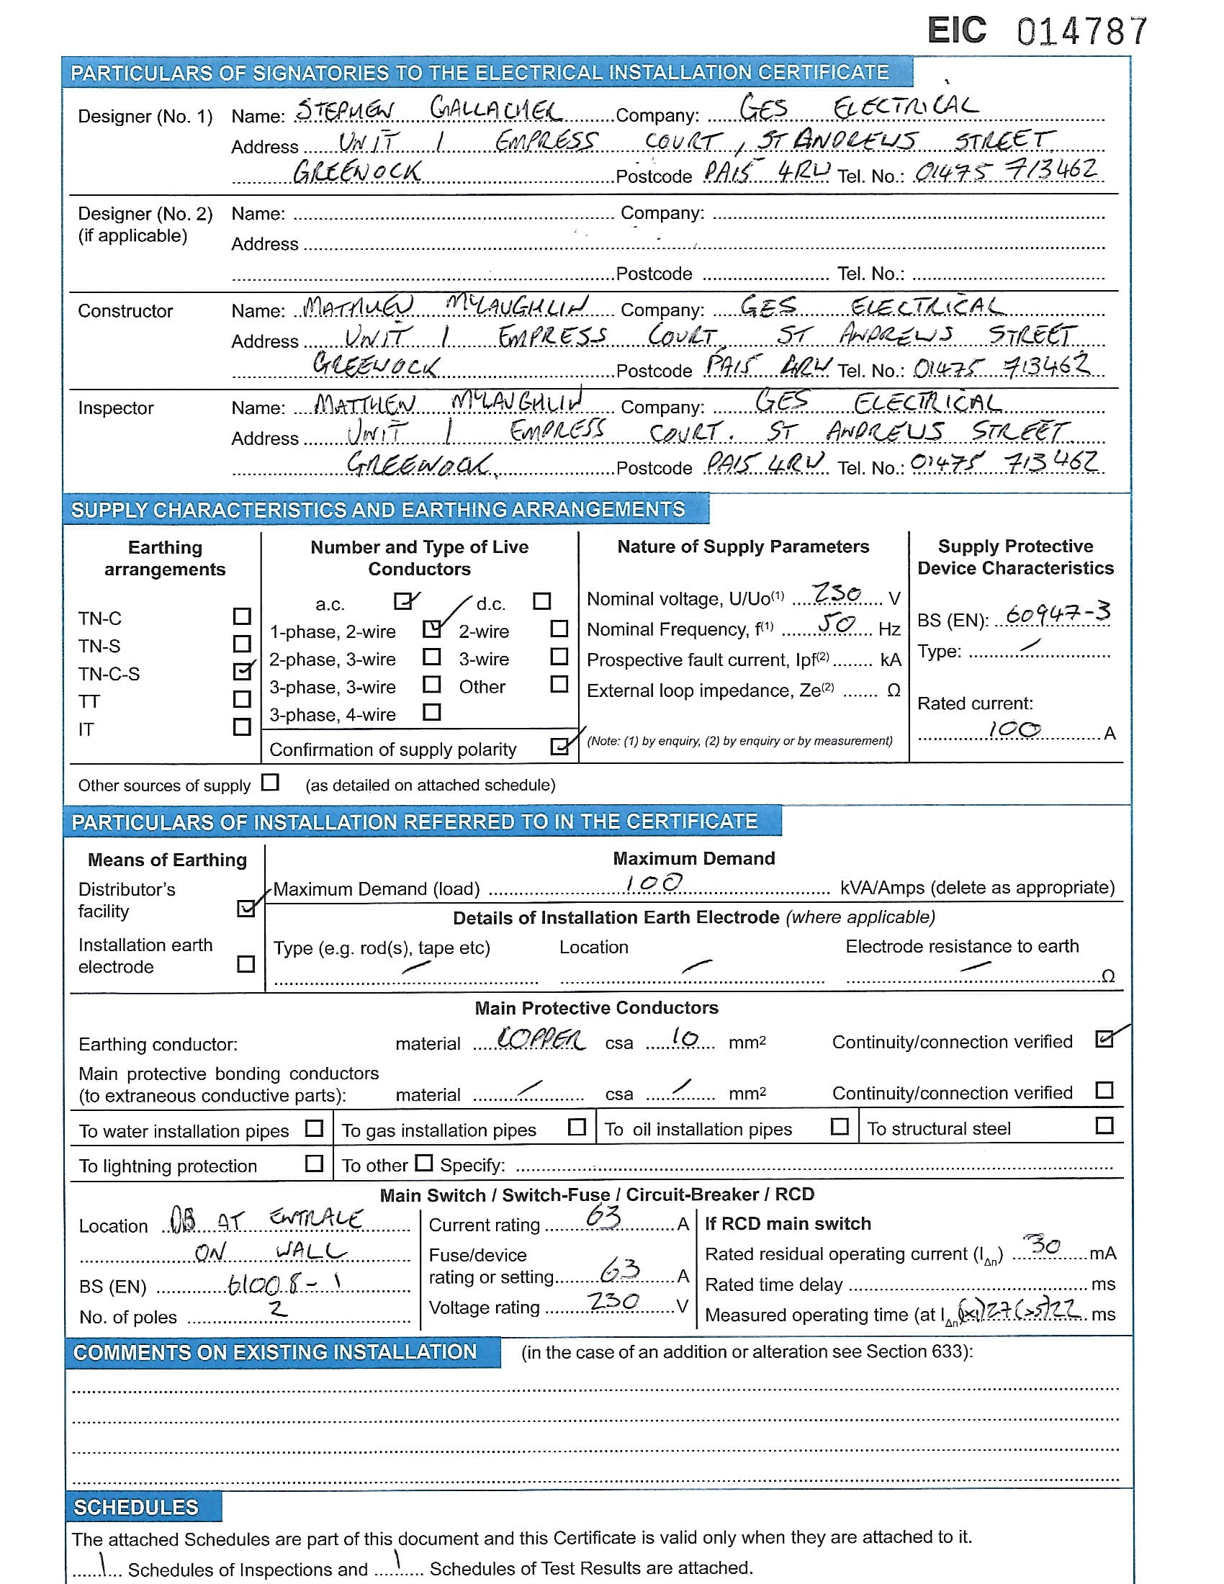

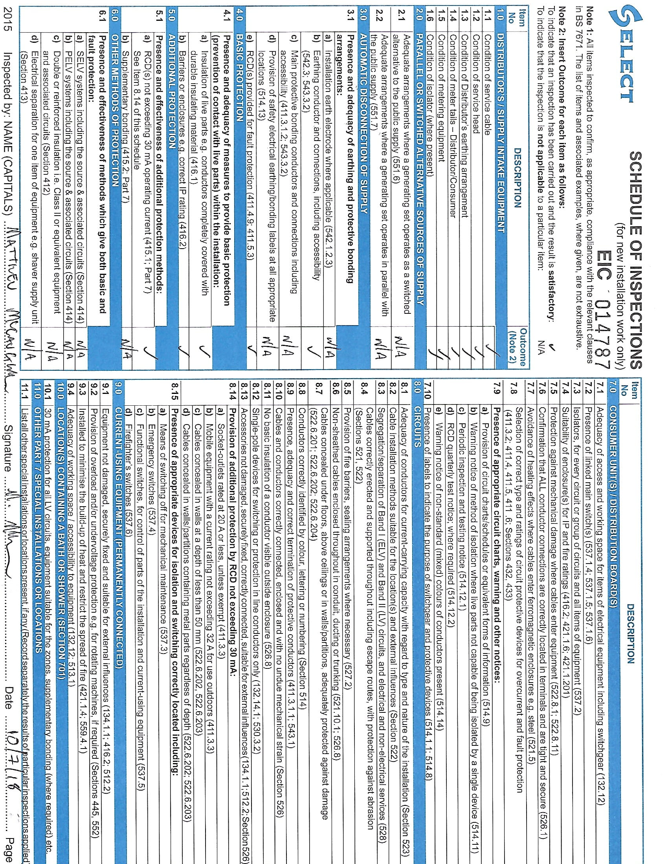
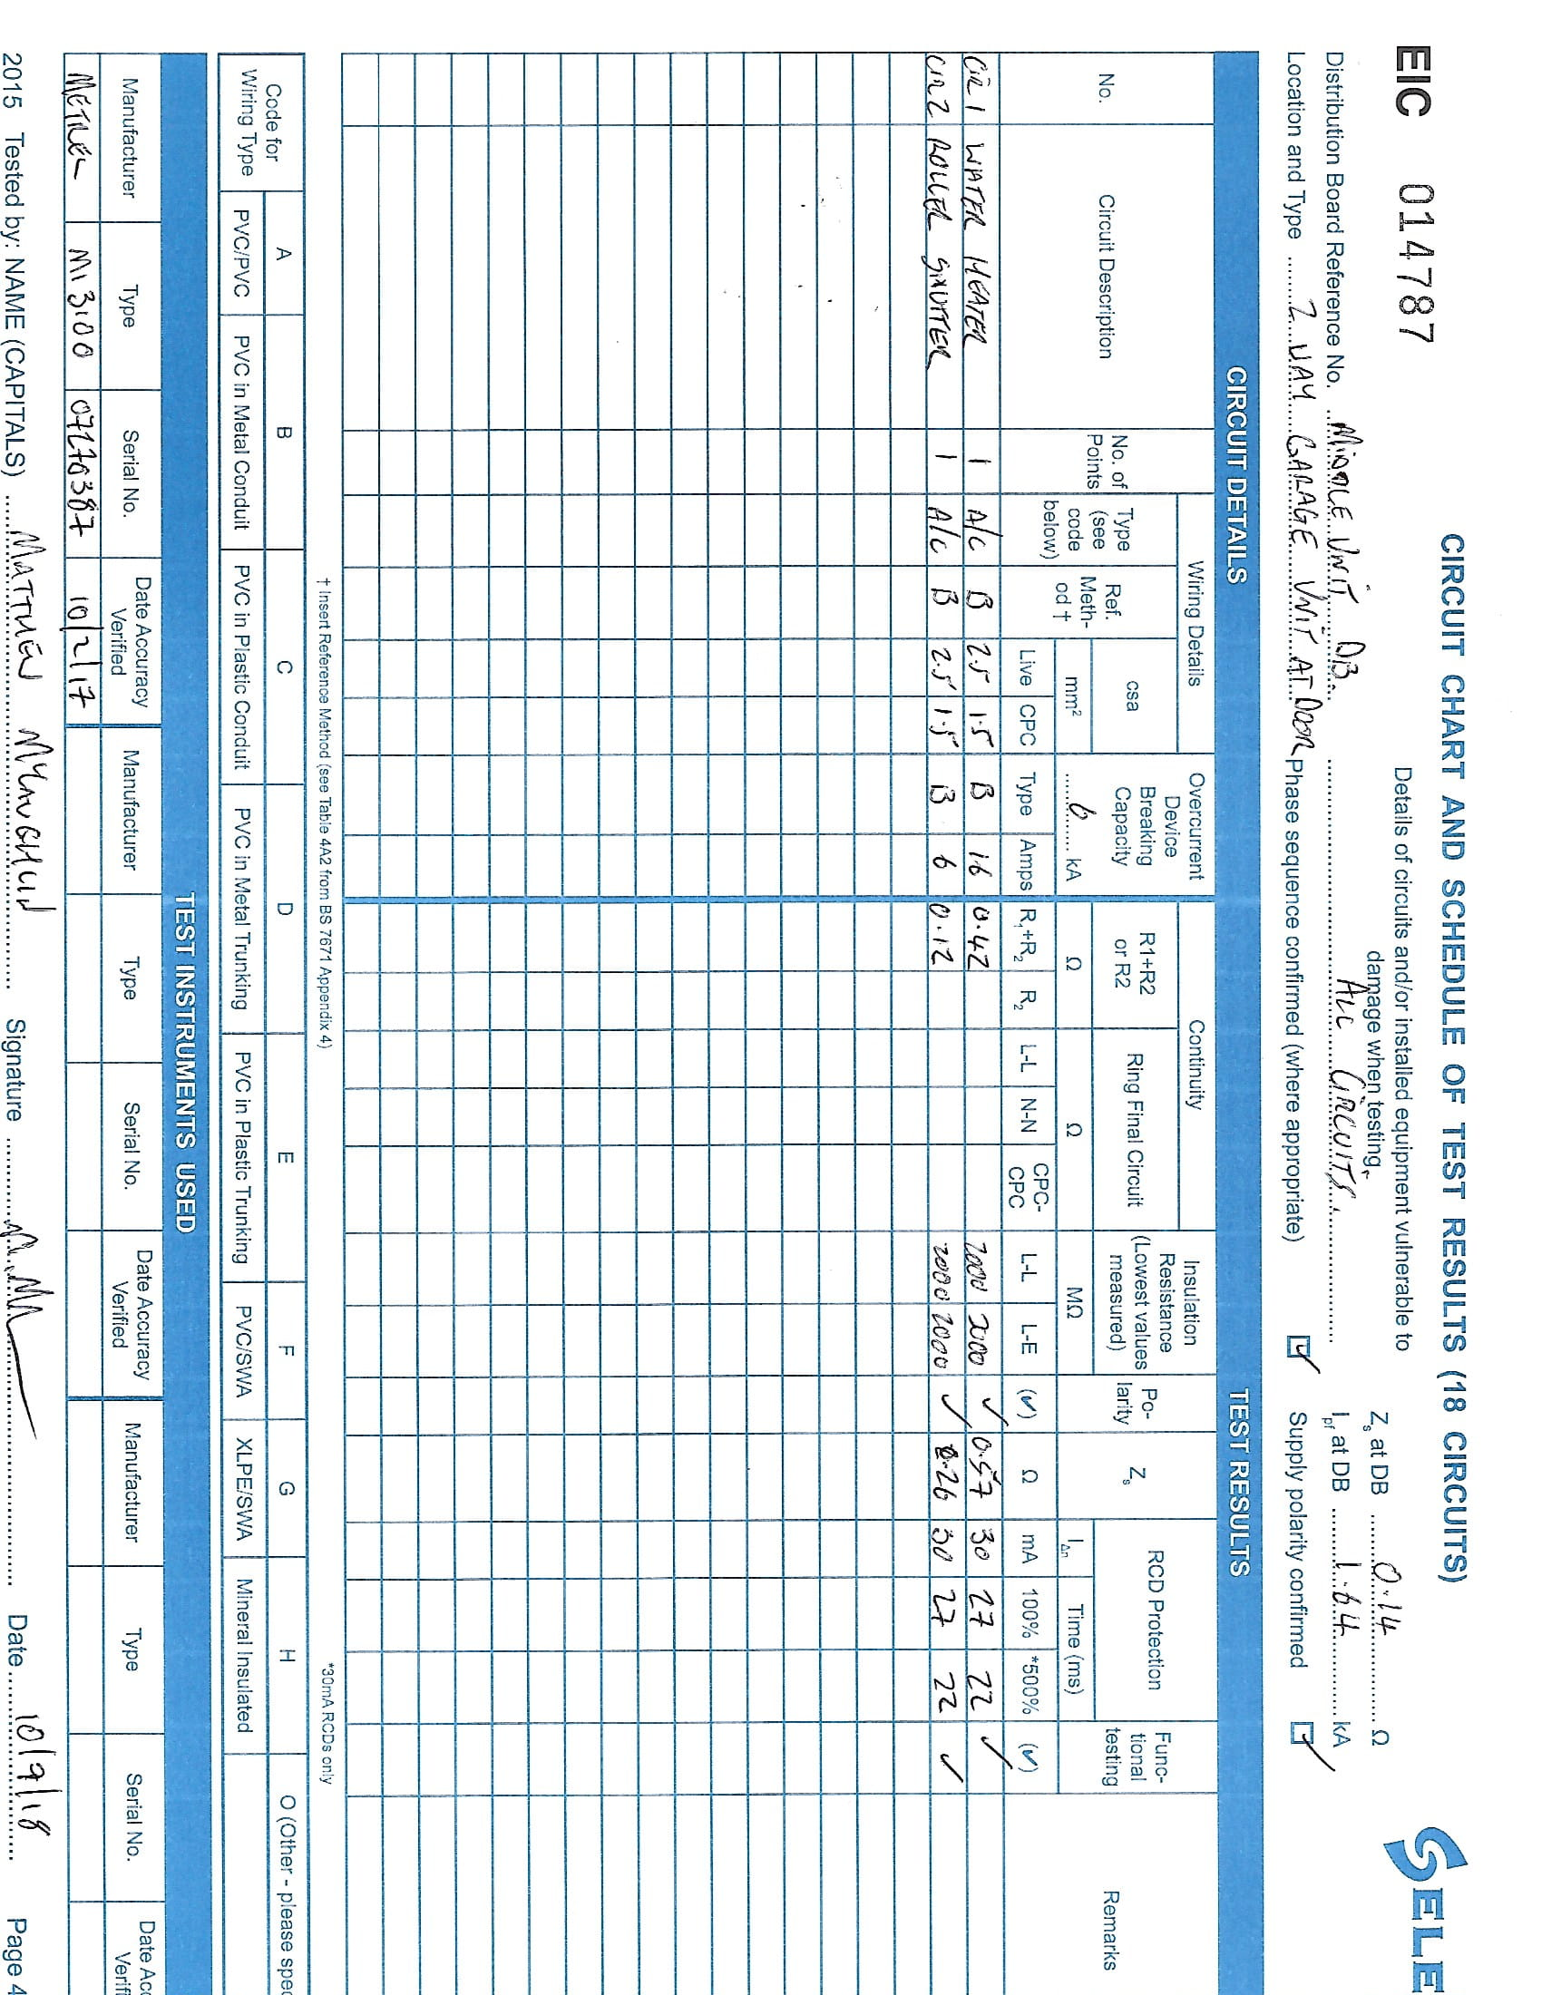

S E C T I O N N I N E.

Contract Drawings

