O & M MANUAL

Clark Contracts

SPT Broomloan Depot

GES141

GES ELECTRICAL LTD
42 Victoria Road
Gourock
PA19 1DB
Tel/Fax 01475 713462

I N D E X

D E S C R I P T I O N S E C T I O N No.

Introduction 1

Warning Notes 2

Operating Instruction 3

Servicing 4

Light Fittings/Spares and Parts List 5

Distribution Panel/Parts List 6

Cable/Miscellaneous List 7

Inspection & Test Certificates 8

Contract Drawings 9

S E C T I O N O N E.

Introduction.

GES ELECTRICAL LTD carried out the electrical installation at SPT Broomhill.

This operation manual provides detailed information for maintenance engineers in the future for guidelines of replacement part and guidelines to maintenance.

No arbitrarily ruling can be given regarding the length of time to lapse between periodic inspection as obviously this depends on the client and the infrastructure of maintenance, security, site environmental and climate conditions. We as a company would recommend that the client implements a maintenance schedule to be carried out on a regular basis, experienced personnel in the electrical field should implement this and a form of record left in this file.

It should be noted that before carrying out any maintenance checks or adjustments of any electrical components, the equipment should be isolated and locked off from the source of electrical power supply.

For and on behalf of

GES ELECTRICAL LTD

S E C T I O N T W O.

WARNING NOTES.

- Do not fit fuses and MCB of larger capacity than supplied within the electrical distribution panel or any fusible item.

- Make sure a full compliment of spare parts e.g. lamps for light fittings are always available, particularly parts most often replaced, and a record left.

- Maintenance should be carried out by experienced, qualified electrical personnel only and safe isolation procedures implemented at all times when works are being carried out.

- The cause of any circuit breaker to trip must be investigated and eliminated at all times

before the power be reapplied to any circuit.

S E C T I O N T H R E E.

Operating Instructions.

Electrical Distribution

- The main electrical distribution is situated in the basement level of the building. Scottish power cable head is situated to the left hand side of the main electrical panel’ with there 3-phase 4.5v main switch situated on the wall next to the mains panel, this switch if switched to the “OFF” position would isolate the main incoming power supply to the electrical installation within the building.

- Localised isolation of circuits can be done from the main electrical panel. All circuit breakers have a legend explaining a brief detail of its operation located to the centre of the panel. Each circuit breaker clearly states whether it is in the “ON” position or the “OFF” position for maintenance purposes circuit breakers should be locked off and labelled clearly that personnel are working on circuit, we recommend that a clear procedure be put in place by client to ensure that this is adhered to at all times and by Experienced electrical personnel only.

Lighting

- All light fittings are operated via localised switches in each room of building.

Emergency Lighting

- Next to each light switch an emergency light test switch is located this is for maintenance purposes only – please refer to emergency lighting section for a more detailed account of operation.

Power Socket Outlets

- All socket outlets are 240v 13amp 3-pin outlets, please note that all appliances should have correct fuse value installed and be certified portable appliance tested. All socket outlets have RCD protection.

Fire Alarm

- Fire Alarm System is a fully automated system, consisting of fire alarm panel situated at front entrance, combined sounder and smoke detection situated at the roof level and emergency break glasses situated at each exit/entrance to building.

Outside Lighting

1. Outside lighting can be operated via switch in the main reception area located on side wall of I.T. cupboard.

S E C T I O N F O U R.

Servicing.

SERVICING OF THE CONTROL GEAR, SWITCH GEAR, LIGHTING, FIRE ALARM SYSTEM – Should be carried out by Experience Personnel only.

- Inspect for loose connections, and tighten nuts, bolts, electrical connections, care should be taken when removing any covers, always make sure all exposed electrical connections have been isolated before carrying out any servicing.

- Examine all switches, control gear, distribution, and lighting socket outlets for signs of overheating or wear and tear, replace if necessary.

- Check all fuses have the correct rating and are in healthy condition.

- Log and report all servicing and list all new parts within this folder.

S E C T I O N F I V E.

S E C T I O N S I X.

S E C T I O N S E V E N.

Cable

4MM BLACK CABLE REF: 6943XLH

SUPPLIER ELECTRIC CENTRE PH 01475 552500

S E C T I O N E I G H T.

Inspection & Test Certificates

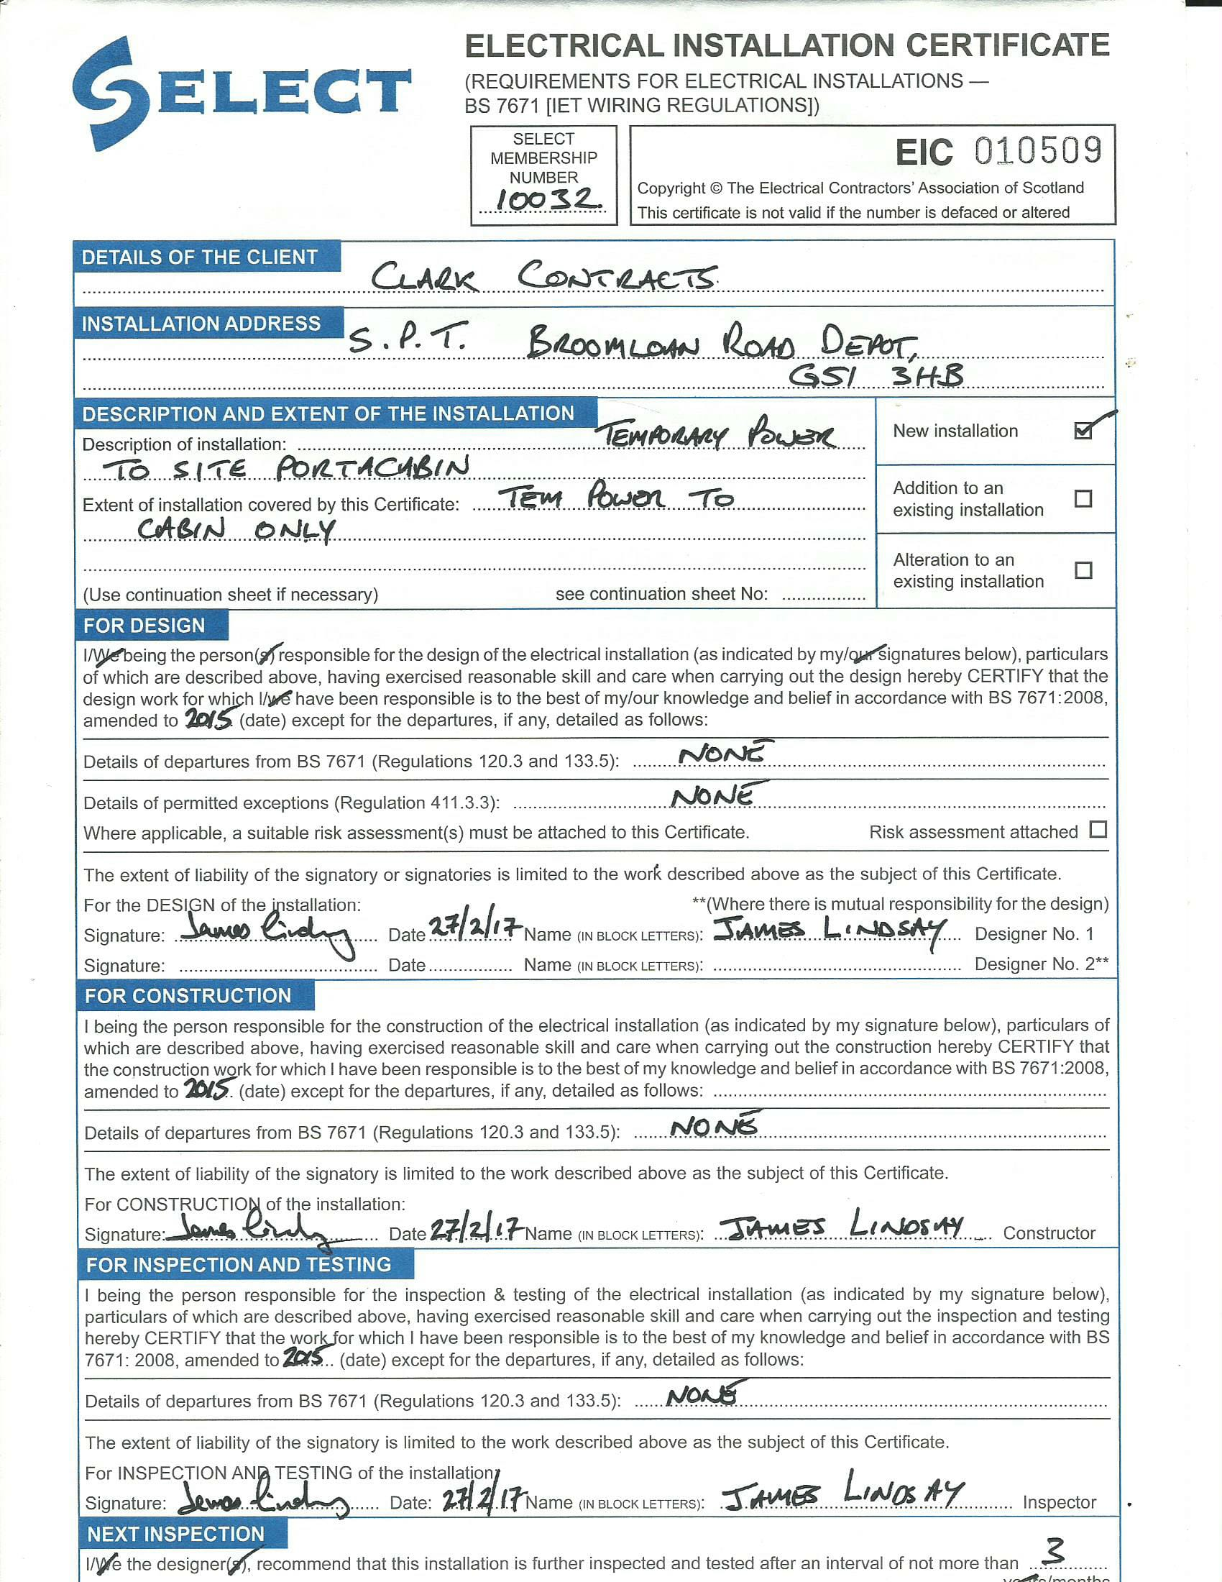
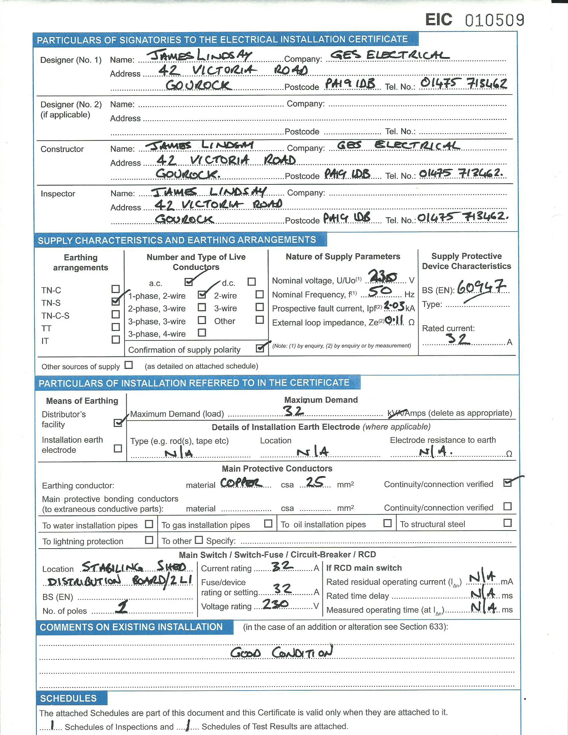

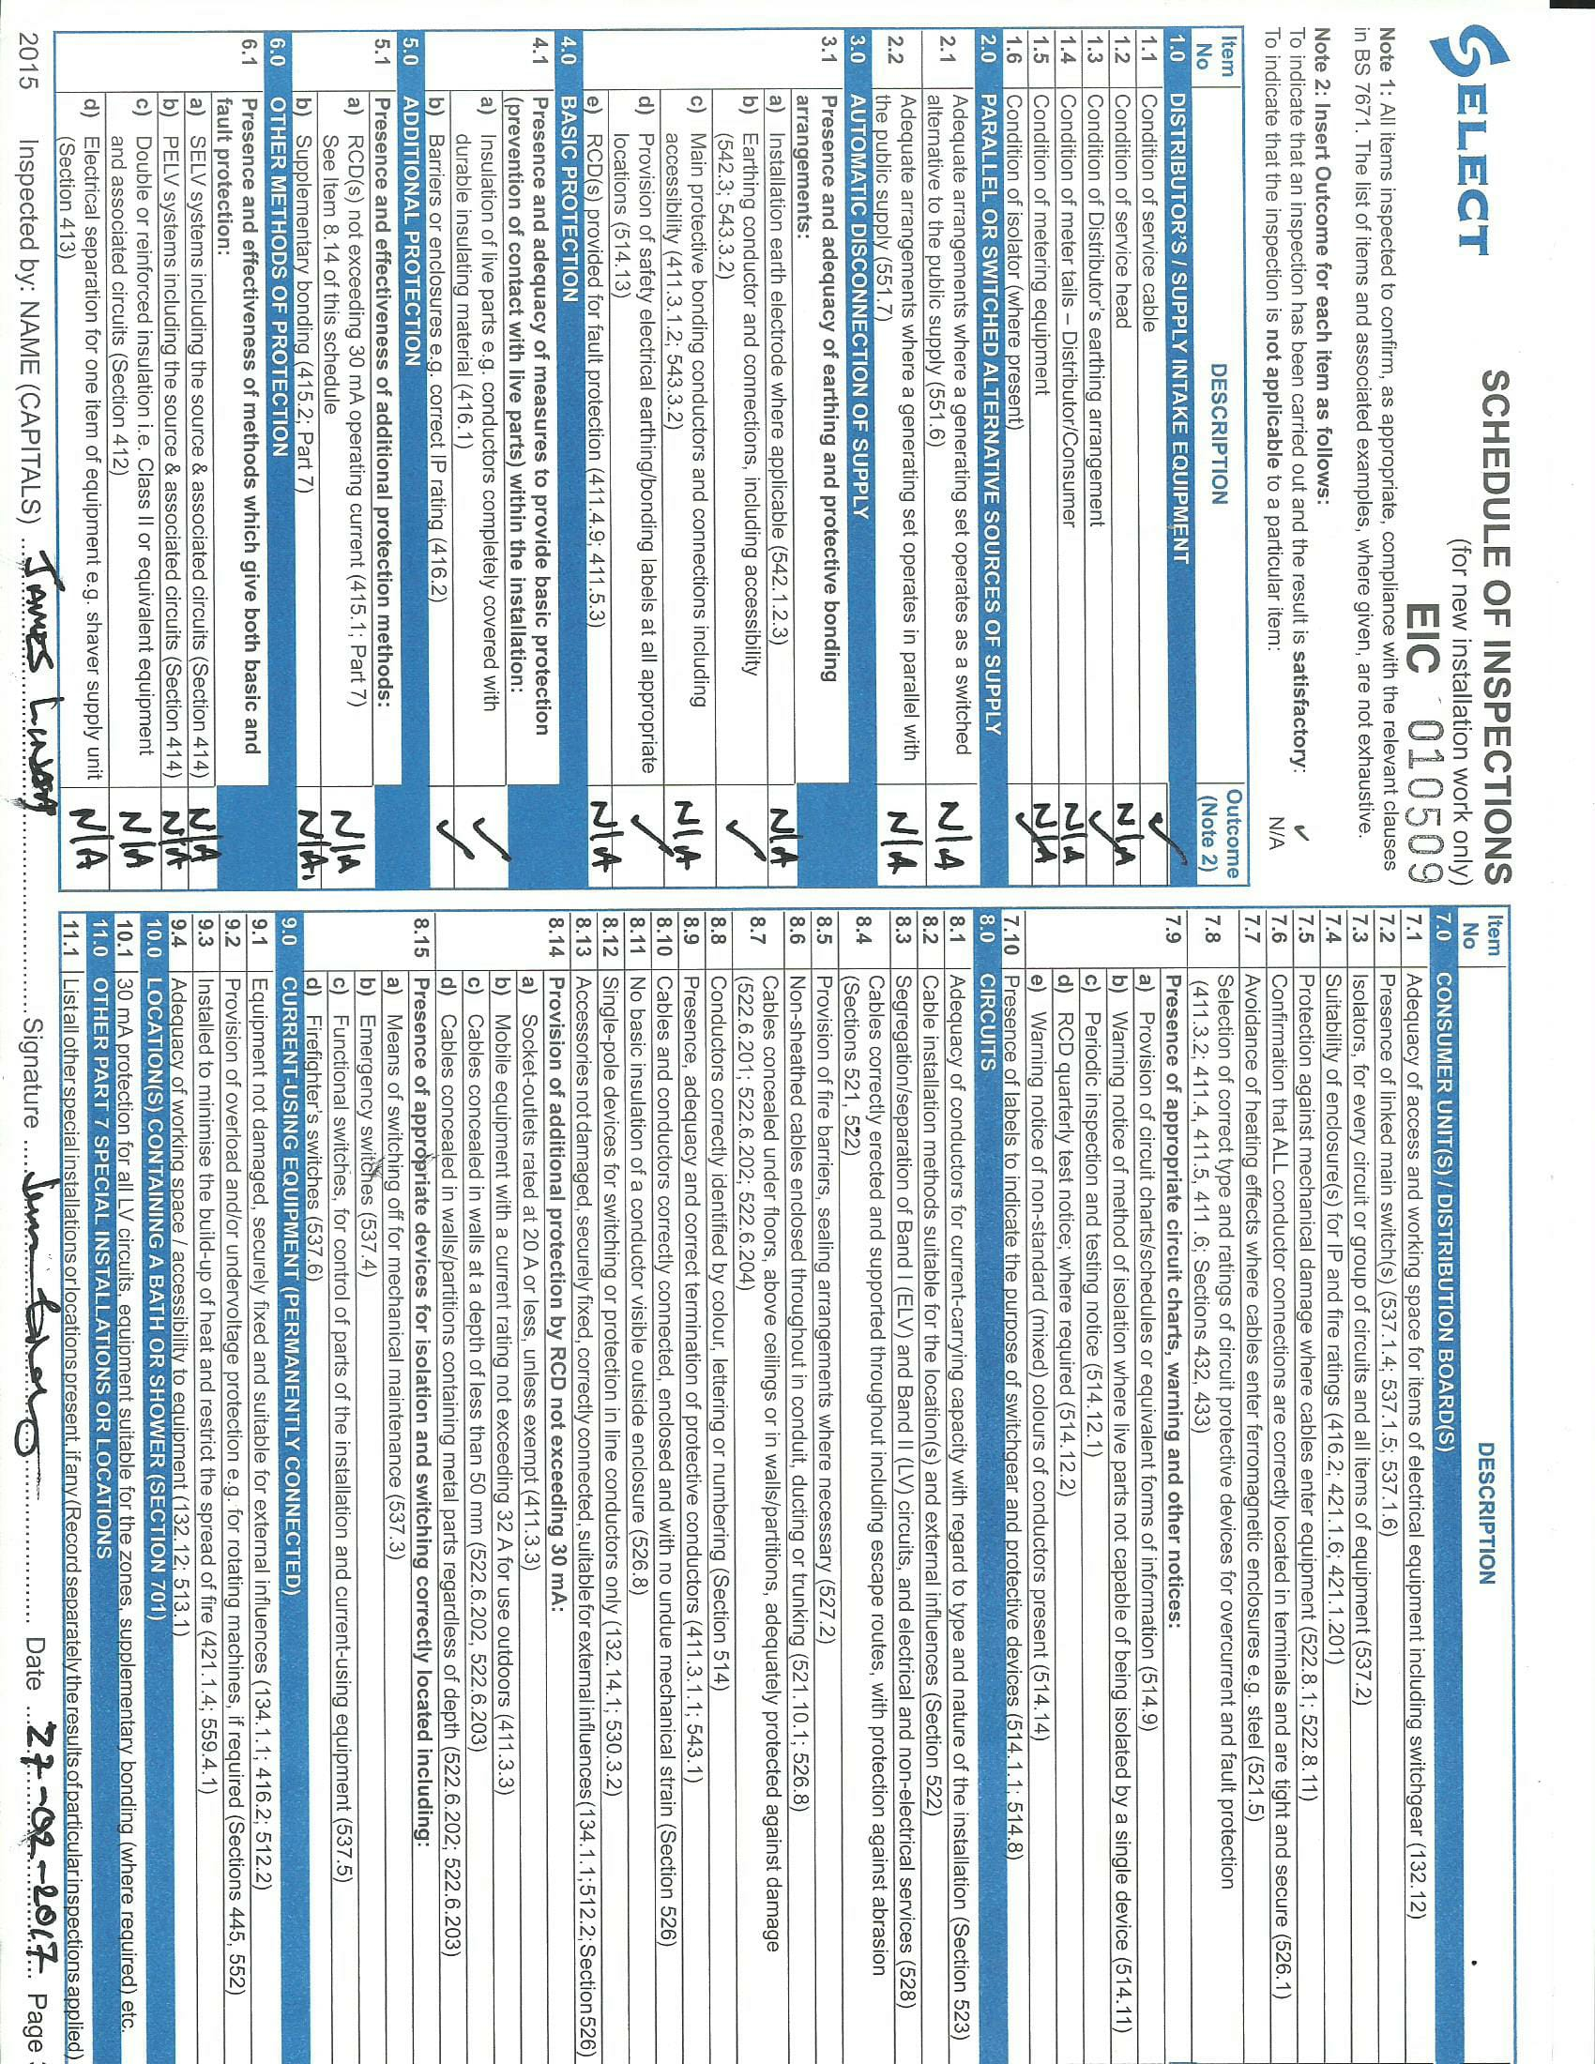

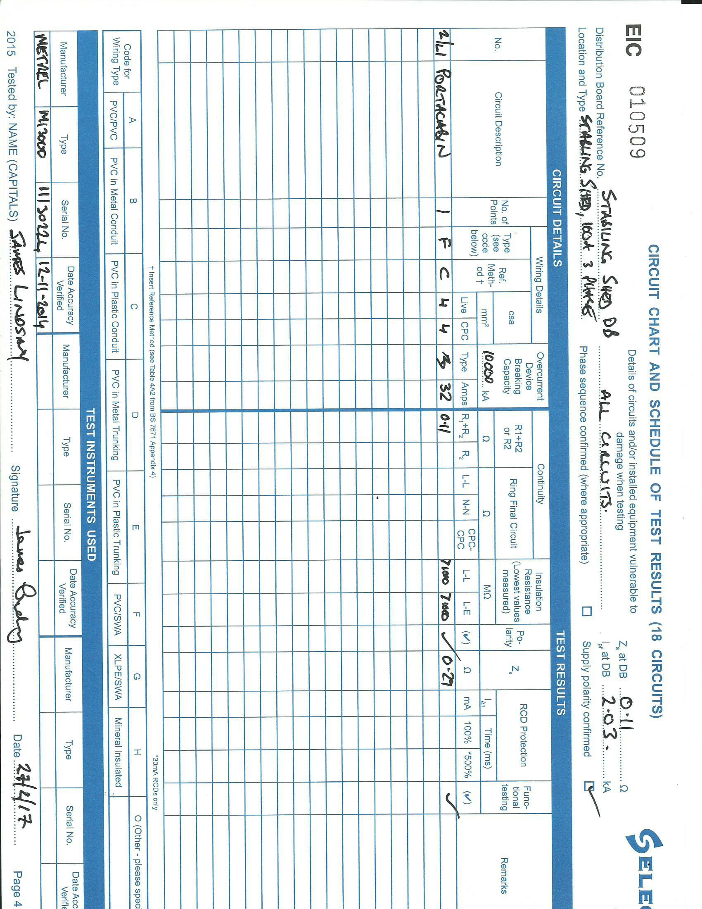

S E C T I O N N I N E.

Contract Drawings

