O & M MANUAL

Clark Contracts

Babcock Marine Pass Office & MGS Building
GES132

GES ELECTRICAL LTD
42 Victoria Road
Gourock
PA19 1DB
Tel/Fax 01475 713462

I N D E X

D E S C R I P T I O N S E C T I O N No.

Introduction 1

Warning Notes 2

Operating Instruction 3

Servicing 4

Light Fittings/Spares and Parts List 5

Distribution Panel/Parts List 6

Fire Alarm Panel/Parts List 7

Tempest Filter 8

Cable/Miscellaneous 9

Heater 10

Contract Drawings 11

Inspection & Test Certificates 12

S E C T I O N O N E.

Introduction.

GES ELECTRICAL LTD carried out the electrical installation at Babcock Marine Pass Office & MGS Building.

This operation manual provides detailed information for maintenance engineers in the future for guidelines of replacement part and guidelines to maintenance.

No arbitrarily ruling can be given regarding the length of time to lapse between periodic inspection as obviously this depends on the client and the infrastructure of maintenance, security, site environmental and climate conditions. We as a company would recommend that the client implements a maintenance schedule to be carried out on a regular basis, experienced personnel in the electrical field should implement this and a form of record left in this file.

It should be noted that before carrying out any maintenance checks or adjustments of any electrical components, the equipment should be isolated and locked off from the source of electrical power supply.

For and on behalf of

GES ELECTRICAL LTD

S E C T I O N T W O.

WARNING NOTES.

- Do not fit fuses and MCB of larger capacity than supplied within the electrical distribution panel or any fusible item.

- Make sure a full compliment of spare parts e.g. lamps for light fittings are always available, particularly parts most often replaced, and a record left.

- Maintenance should be carried out by experienced, qualified electrical personnel only and safe isolation procedures implemented at all times when works are being carried out.

- The cause of any circuit breaker to trip must be investigated and eliminated at all times before the power be reapplied to any circuit.

S E C T I O N T H R E E.

Operating Instructions.

Electrical Distribution

- The main electrical distribution is situated in the basement level of the building. Scottish power cable head is situated to the left hand side of the main electrical panel’ with there 3-phase 4.5v main switch situated on the wall next to the mains panel, this switch if switched to the “OFF” position would isolate the main incoming power supply to the electrical installation within the building.

- Localised isolation of circuits can be done from the main electrical panel. All circuit breakers have a legend explaining a brief detail of its operation located to the centre of the panel. Each circuit breaker clearly states whether it is in the “ON” position or the “OFF” position for maintenance purposes circuit breakers should be locked off and labelled clearly that personnel are working on circuit, we recommend that a clear procedure be put in place by client to ensure that this is adhered to at all times and by Experienced electrical personnel only.

Lighting

- All light fittings are operated via localised switches in each room of building.

Emergency Lighting

- Next to each light switch an emergency light test switch is located this is for maintenance purposes only – please refer to emergency lighting section for a more detailed account of operation.

Power Socket Outlets

- All socket outlets are 240v 13amp 3-pin outlets, please note that all appliances should have correct fuse value installed and be certified portable appliance tested. All socket outlets have RCD protection.

S E C T I O N F O U R.

Servicing.

SERVICING OF THE CONTROL GEAR, SWITCH GEAR, LIGHTING, FIRE ALARM SYSTEM – Should be carried out by Experience Personnel only.

- Inspect for loose connections, and tighten nuts, bolts, electrical connections, care should be taken when removing any covers, always make sure all exposed electrical connections have been isolated before carrying out any servicing.

- Examine all switches, control gear, distribution, and lighting socket outlets for signs of overheating or wear and tear, replace if necessary.

- Check all fuses have the correct rating and are in healthy condition.

- Log and report all servicing and list all new parts within this folder.

S E C T I O N F I V E.

Light Fittings/Lamps

ETERNA 600X600 4K LED PANEL REF: 74190
ETERNA 600X600 LED 4K EMERGENCY PANEL REF: 74190E
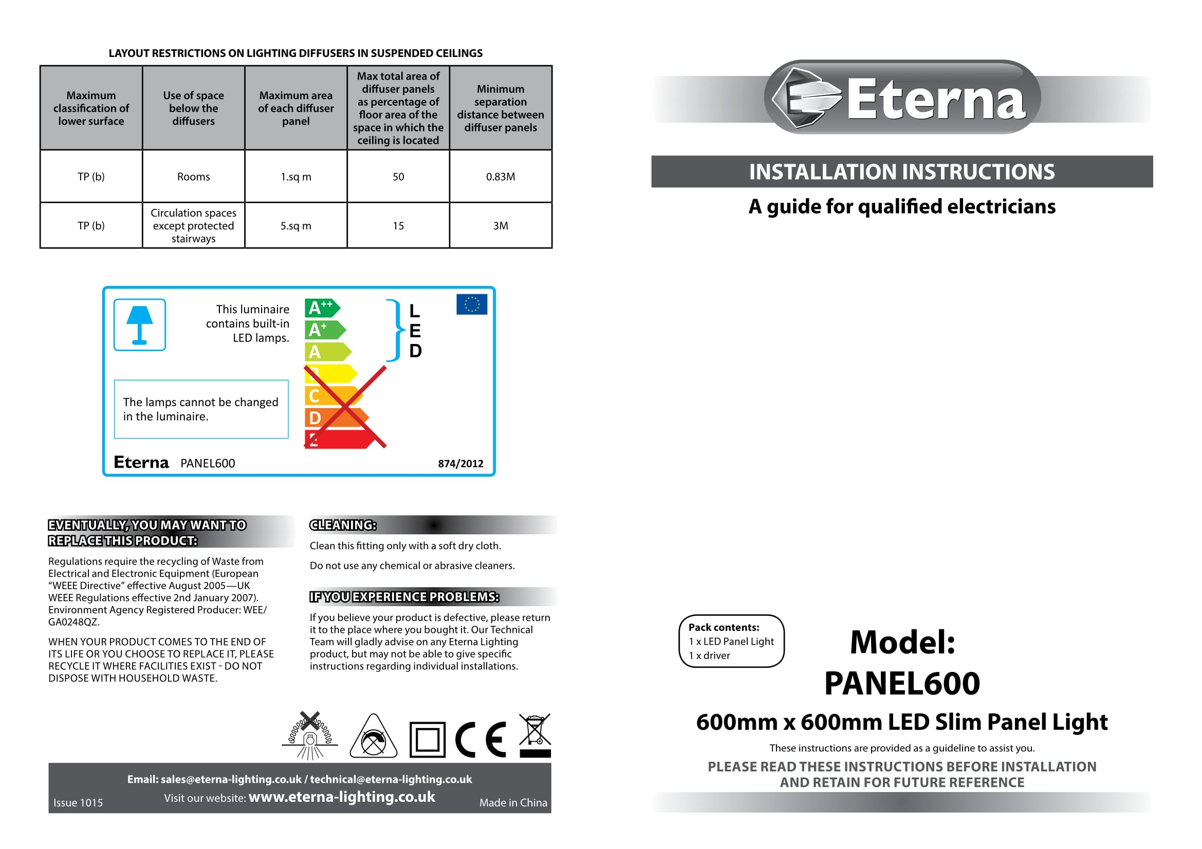
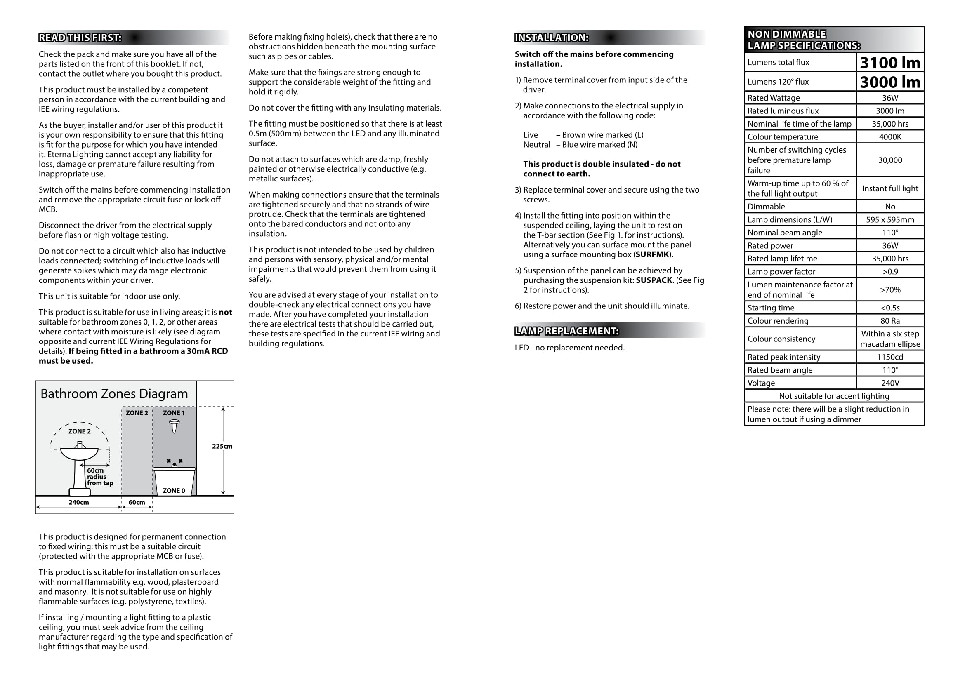
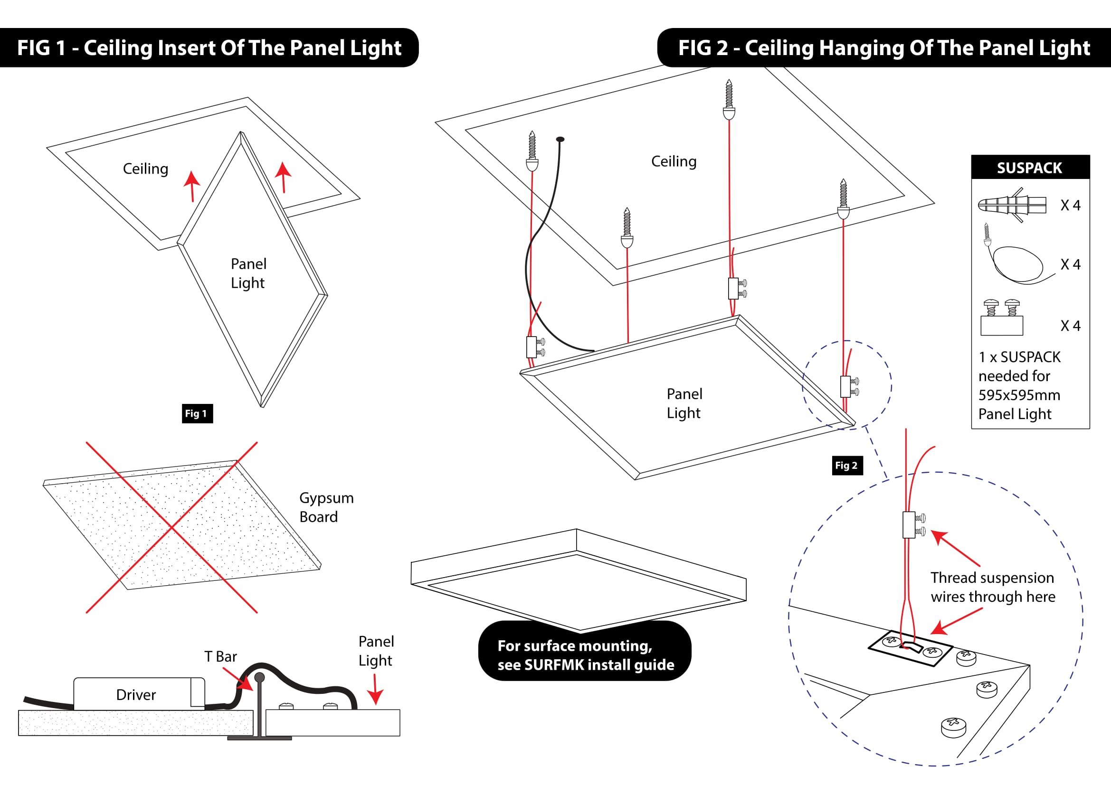

ETERNA EMERGENCY BATTERY PACK REF: EBPM3
BHEATH LUMIN & T8 LED 230V GREY REF: CRL8120

Bheath Lumin & T8 LED 230v Grey 5ft single
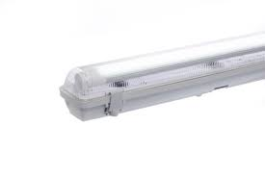
Description The tube+ is a unique LED tube available in standard and emergency versions. The emergency tube has all the control gear built into the tube and intelligently detects the difference between power failure and deliberately switching off the power. Standards • BS EN 55015: 2006 +A1: 2007 +A2: 2009 • BS EN 61547: 2009 • BS EN 61000-3-2: 2006 +A1: 2009 +A2: 2009 • BS EN 61000-3-3: 2008 • BS EN 62471: 2008 • BS EN 62031: 2008 • BS EN 61347-1: 2008 • BS EN 61347-2-13: 2007 • IEC 34A/1501/NP • RoHS 2011/65/EU Features ● 5ft tube works on 110V & 230V ● Unique and intelligent two switch system for emergency control ● Emergency tube has inbuilt batteries and control gear for easy maintenance ● Single end input for increased safety ● 3 hour emergency duration ● Rated life of 30,000 hours ● Lamps have 2 year guarantee ● Pre-wired luminaires available for quick and easy installation Range tube+ 22W 5ft tube T8020 22W 5ft tube + 110V fitting CRL8020 22W 5ft tube + 230V fitting CRL8120 tube+ 22W 5ft EM tube T8021 22W 5ft EM tube + 110V fitting CRL8021 22W 5ft EM tube + 230V fitting CRL8121 Technical Specification Voltage 110-230V ~ 50Hz Lamp T8 5ft LED Wattage 22W Lumen Output T8020 T8021 1950 lumens 2000 lumens 200 lumens in EM mode Colour Temp. 6000K EM Duration 3 hours Beam Angle 120° Operating Temp. -10°C ~ 50°C

SUPPLIER: ELECTRIC CENTER GREENOCK PH. 01475 552500

S E C T I O N S I X.

Distribution Panels/Parts List

32AMP SINGLE MODULE RCBO TYPE C
16AMP 10KA SINGLE RCBO TYPE B

SUPPLIER: CEF GREENOCK PH. 01475 723206

WYLEX RCBO SP TYPE C 32A 30MA REF: NSBS32/1

SUPPLIER: ELECTRIC CENTER GREENOCK PH. 01475 552500

S E C T I O N S E V E N.

Fire Alarm Panel/Parts List

S E C T I O N E I G H T.

Tempest Filter

TEMPEST FILTER 4 X OUTLET 13A 250VAC 50/60HZ REF: DS30835

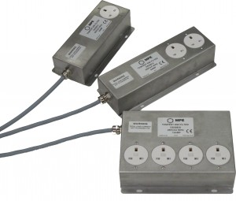

TEMPEST Pluggable Filters
MPE Limited’s range of TEMPEST pluggable filters has been designed for use within the most stringent TEMPEST applications, where compliance to SDIP-27 B/C is required. Utilising ultra-high speed feed through capacitors, all units deliver optimum performance across the full frequency range and under all loading conditions. The filter range has been designed to ensure fitting and electrical installation is as quick and simple as possible.

DESCRIPTION

- TEMPEST EMI SP & N filter providing performance to SDIP-27 B/C
- Insertion loss of 60dB from 1MHz to 1GHz
- 6A & 13A BS1363 3 pin plug & socket outlets
- 32A IEC 60309 ‘Commando’ connector input & socket outlets
- *alternatively terminated filters (e.g. Powercon, Schuko, IEC etc.) are available upon request
- Designed to IT equipment safety standard EN60950-1
- Fully 360⁰ screened input cable to maintain red/black separation to filter
- Low Smoke Zero Halogen (LSZH) rated cabling for use in sensitive areas
- Self-healing metallised plastic film capacitors
- Rugged magnetic stainless steel enclosure
- 6A and 13A designs of filter are downline tolerable to a personnel protection RCCD
- CE compliant
- Simple mechanical and electrical installation

RATINGS AND CHARACTERISTICS
Rated Voltage 250V ac 50/60Hz
Test Voltage (line – earth) 2250V dc
Test Voltage (line – line) 1250V dc
Rated Current, I_{R} at 50°C 6A, 13A, 32A
Earth Leakage Current: 6A & 16A less than 3.5mA, 32A less than 35mA
Maximum Temperature Rise on Full Load 25˚C
Operating Temperature Range -25˚C to 50˚C
Insertion Loss (50Ω, asymmetric) 60dB from 100 kHz to 1GHz
Discharge Time Less than 1s to below 34V
Enclosure Stainless steel
Finish Natural, brushed

STANDARD RANGE – UK
 | Single Outlet | Dual Outlet | Quad Outlet | In-Line
6A | DS30830 | DS30831 |  | DS30832
13A | DS30833 | DS30834 | DS30835 | DS30836
32A |  | DS30837 | DS30838 | DS30839

STANDARD RANGE – EU
 | Single Outlet | Dual Outlet | Quad Outlet | In-Line
6A | DS30830EU | DS30831EU |  | DS30832EU
13A | DS30833EU | DS30834EU | DS30835EU | DS30836EU
32A |  | DS30837EU | DS30838EU | DS30839

STANDARD RANGE – Republic of Korea
 | Single Outlet | Dual Outlet | Quad Outlet | In-Line
6A | DS30830ROK | DS30831ROK |  | DS30832ROK
13A | DS30833ROK | DS30834ROK | DS30835ROK | DS30836ROK
32A |  | DS30837ROK | DS30838ROK | DS30839
MPE TEMPEST Pluggable Filters Overview October 2014
TEMPEST Pluggable Filter Range Ver2.4 October 2014
TEMPEST Pluggable Filter Range European Ver2.3 October 2014
TEMPEST Pluggable Filter Range Korea Ver2.3 October 2014
DS30830 6A Single Outlet
DS30831 6A Dual Outlet
DS30833 13A Single Outlet
DS30834 13A Dual Outlet
DS30835 13A Quad Outlet
DS30838 32A Quad Outlet

SUPPLIER: MPE LTD, LIVERPOOL PH. 0151 632 9100

S E C T I O N N I N E.

Cable

FP200 4mm 2-C & EARTH CABLE
2.5MM LSF S-CORE CABLE

SUPPLIER: HOLLAND HOUSE GREENOCK PH. 01475 784431

Miscellaneous

40X40MM PVC TRUNKING
END CAP
20MM PVC CONDUIT
2-G IP RATED LIGHT SWITCH
2-GANG SOCKET
1-GANG SOCKET
DOUBLE POLE SWITCH
2-GANG GRID SWITCH WITH EM KEY SWITCH

SUPPLIER: ELECTRIC CENTER GREENOCK PH. 01475 552500

S E C T I O N T E N.

Heater
2KW GLEN DIMPLEX CONVECTOR HEATER


SUPPLIER: ELECTRIC CENTER GREENOCK PH. 01475 552500

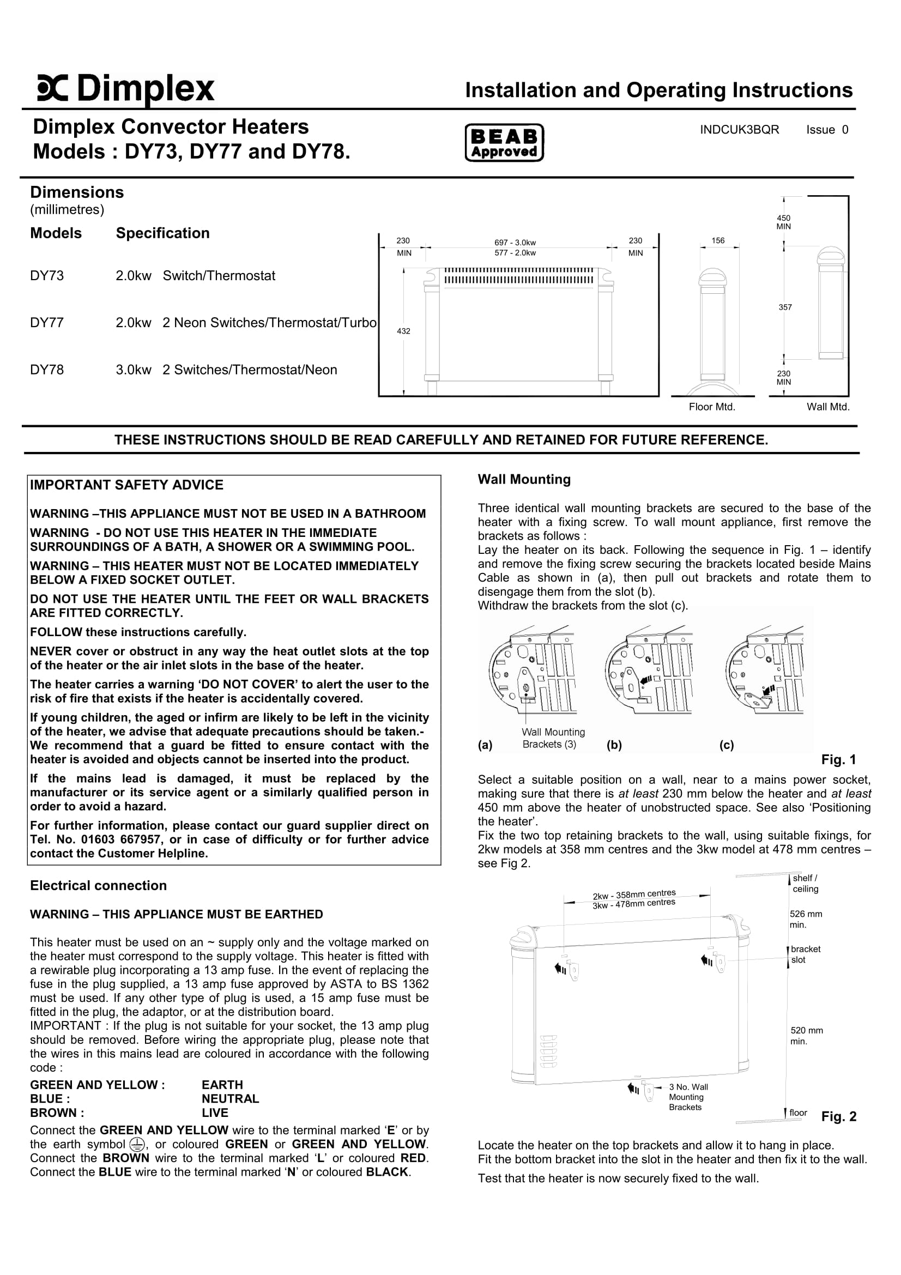
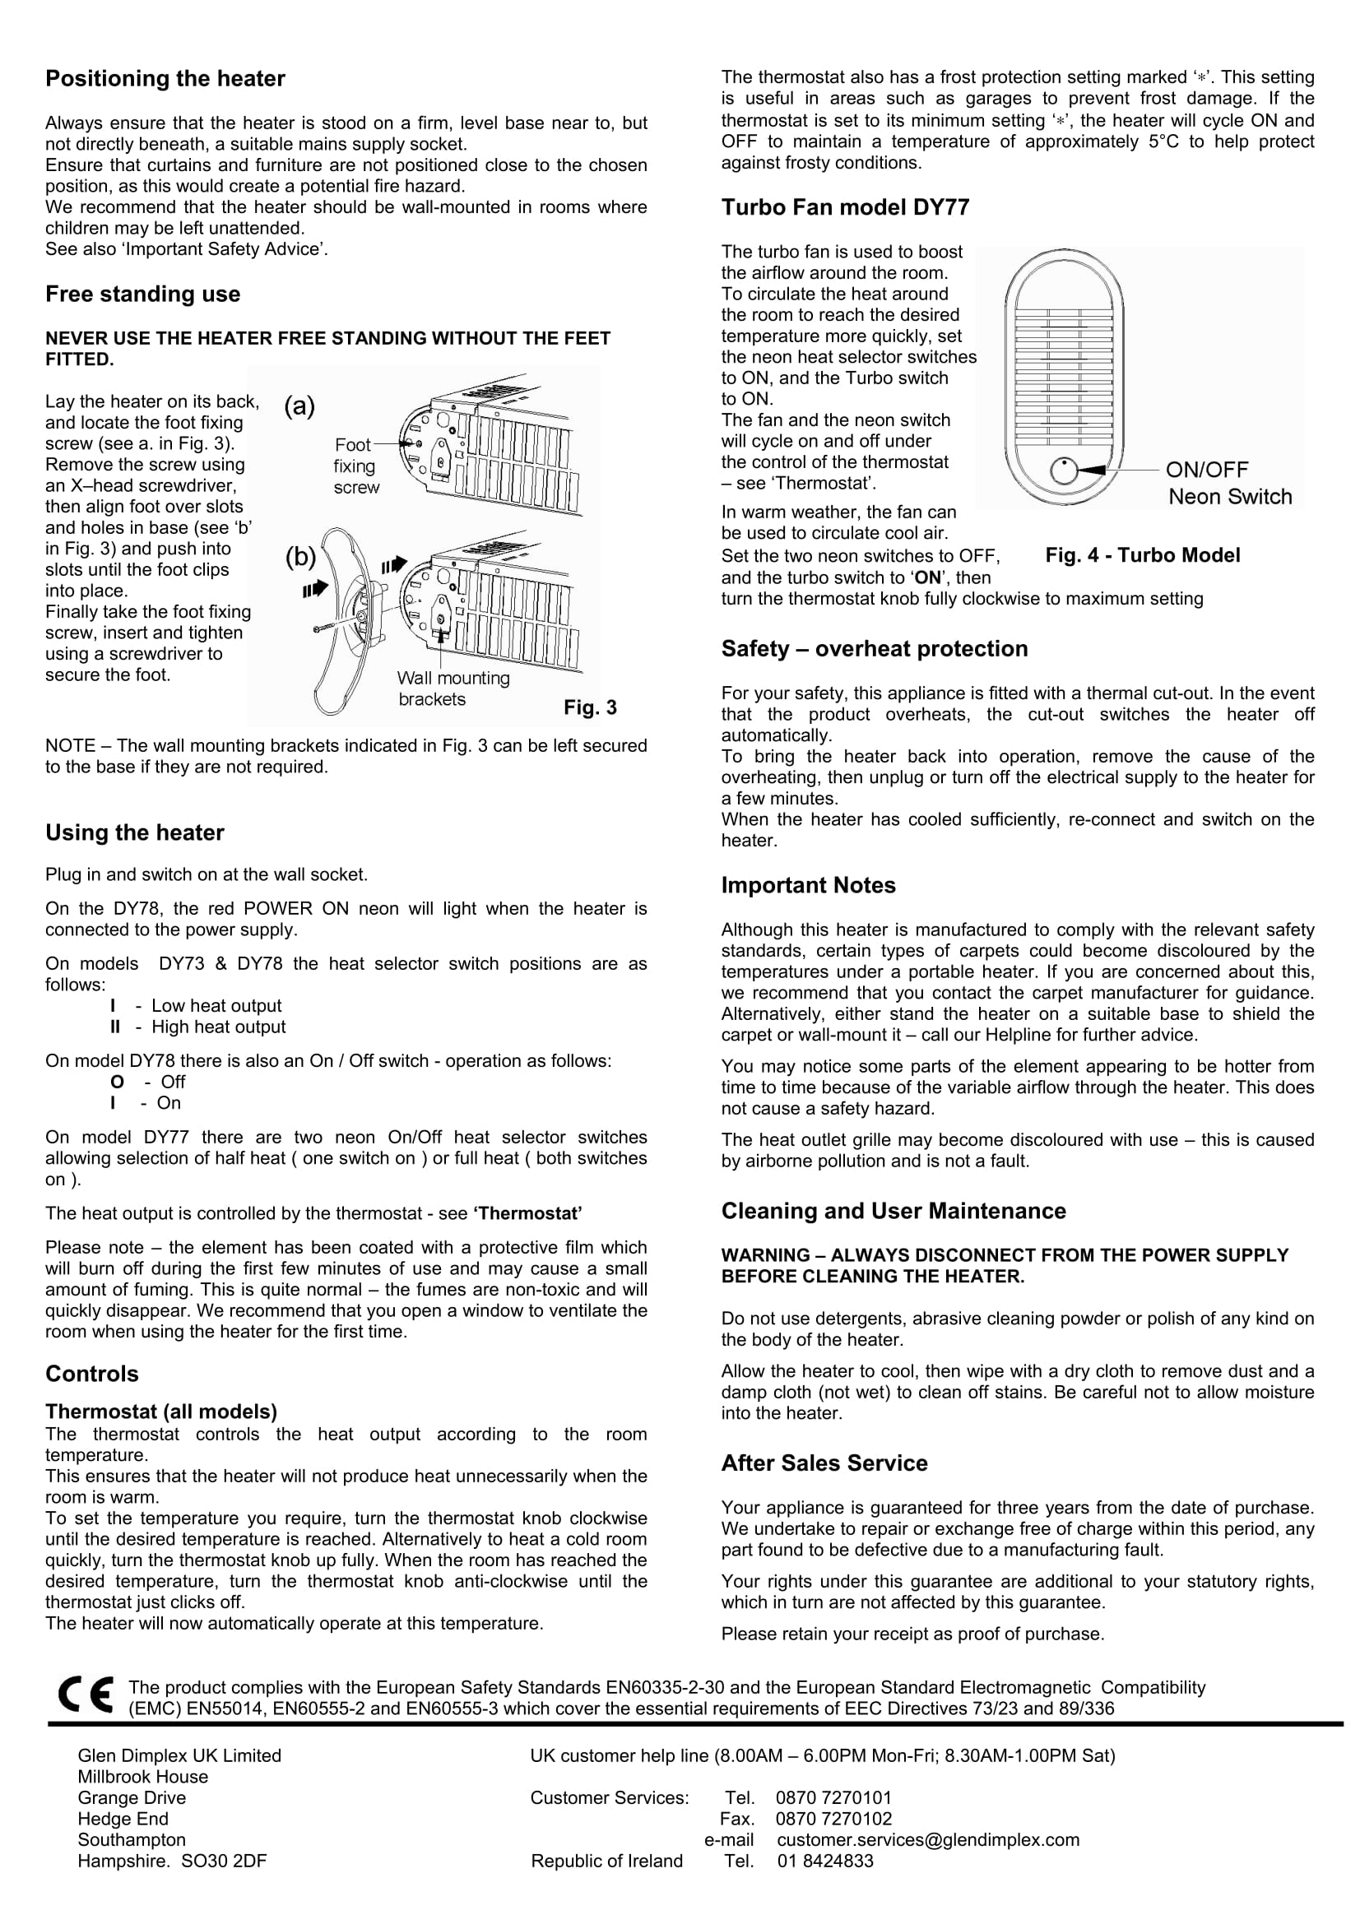
S E C T I O N E L E V E N.

Contract Drawings

S E C T I O N T W E L V E.

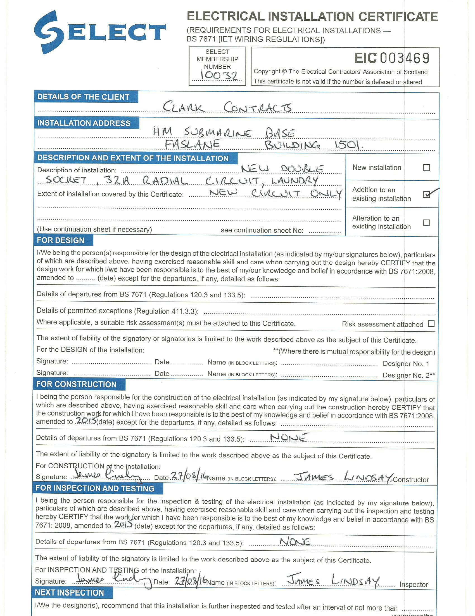
Inspection & Test Certificates

